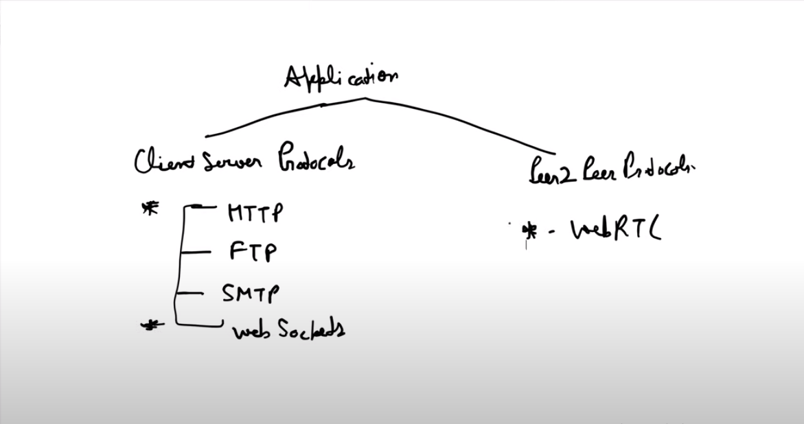

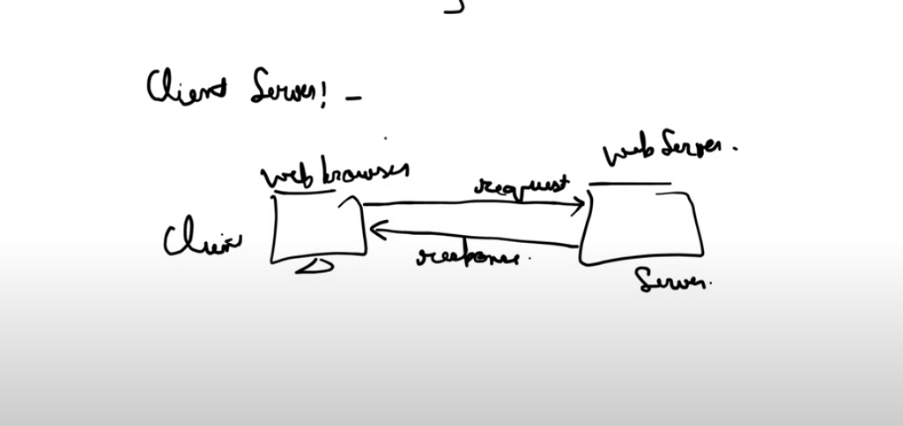

All other than web socket are unidirectional communication protocols i.e client initiates the request and server responds to that request with response. But in case of web sockets the communication is bidirectional ie client can talk to server and server can talk to client.

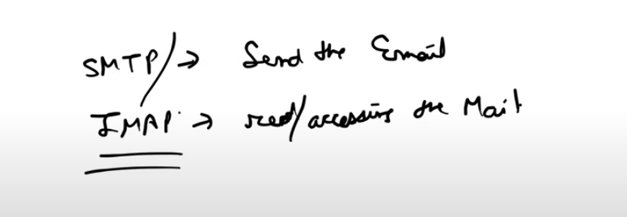

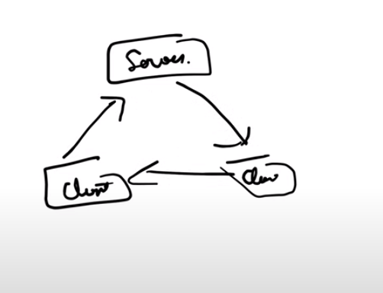

In peer to peer server can talk to client , client can talk to server and client can talk to client.

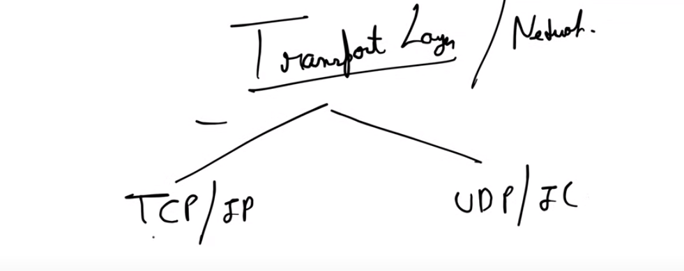

In tcp/ip first virtual connection is maintained and data packets are send with ordering and for each packet received acknowledge to source is sent back and in case if any data packet is lost then that piece of data is sent back again to destination.

In case of udp/ip multiple data packets without ordering and without any acknowledgement are send parrallely so it is fast and the data packet which is lost is lost . for eg in case of vedio streaming and vedio call if you miss something that is lost and can’t be get back. Webrtc is a p2p connection which uses udp/ip protocol for faster communication.

In FTP it establish two connection one control connection and one data connection and data send hrough data connection is plain text instead of decrypted text so we use https as data is sent from https in an encrypted way.

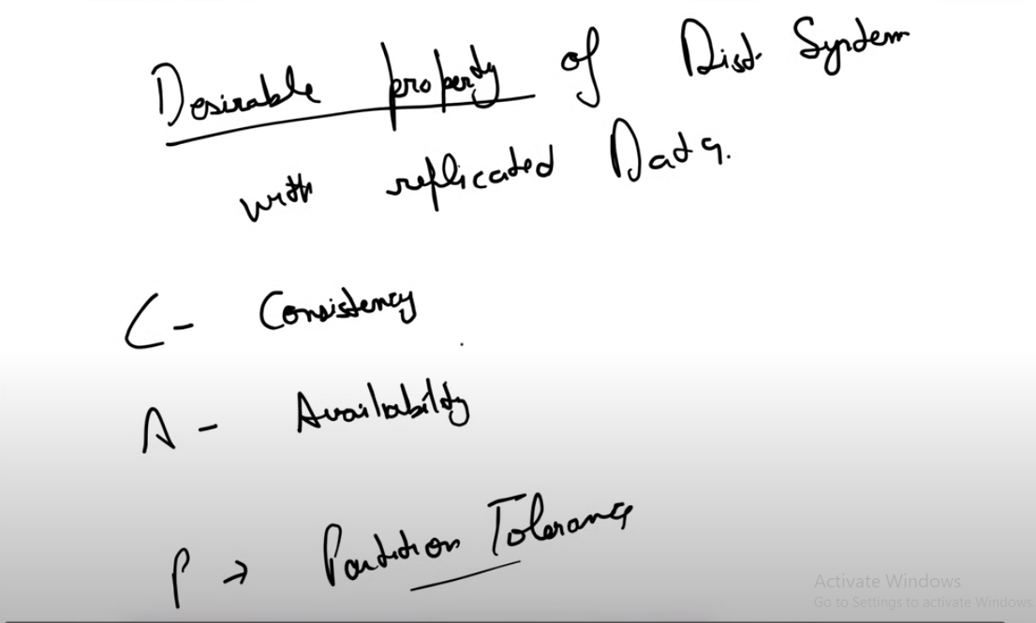

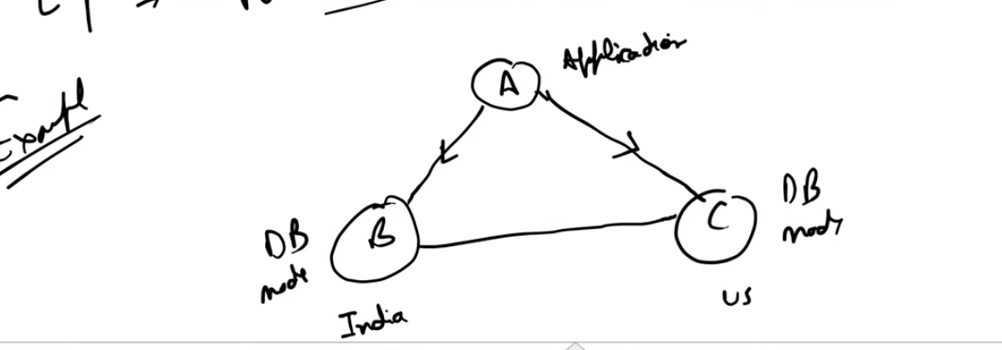

For instance if a writes value of a 5 from 4 then it should also replicate it on node c and if node A reads value of a from node c then it should give value as 5 that is what consistency is.

If I have two data nodes ie node A and node B then when I fetch data from db then atleast all the node should respond ie either success or failure.

If I have write something on db node a and it is updating that value on node c and due to some system failure or partition failure it is unable to write on node c but when user requests something from server then he is able to get response from server doesn’t matter how . so basically the system is up and even on partition failure that is called partition tolerance.

In todays world of distributed system where the system should be highly available at each time interval so partition tolerance is not a tradeoff so we should choose between availability and consistency.

**When to Choose Consistency**

Consistency means that all nodes in a distributed system see the same data at the same time. This is crucial in scenarios where having the most up-to-date and accurate information is essential. Here are some real-life examples where consistency is prioritized:

1. **Banking and Financial Systems**:
   * **Example**: Consider an online banking system. When a user transfers money from one account to another, it’s critical that the transaction is reflected accurately across all systems. If the system were to prioritize availability over consistency, a user might see inconsistent balances, leading to potential overdrafts or duplicate transactions.
   * **Why Consistency**: Financial transactions require strict accuracy and correctness. Inconsistencies could lead to significant financial loss or fraud.
2. **E-commerce Order Processing**:
   * **Example**: In an e-commerce platform, when a customer places an order, it’s vital that the inventory count is accurate to prevent overselling a product. If multiple customers try to purchase the last item simultaneously, the system must ensure that the inventory is updated consistently.
   * **Why Consistency**: Ensuring that the inventory is updated correctly prevents overselling and ensures a smooth customer experience.
3. **Medical Records Systems**:
   * **Example**: In a healthcare environment, patient records need to be consistent across all systems. A doctor needs to see the most up-to-date information about a patient's medications, allergies, and treatment history to make accurate decisions.
   * **Why Consistency**: Inconsistent data in medical records can lead to incorrect diagnoses or treatments, potentially endangering patient lives.

**When to Choose Availability**

Availability means that every request receives a response, even if it might be stale. This is crucial in scenarios where the system must be highly responsive and can tolerate some level of eventual consistency. Here are some real-life examples where availability is prioritized:

1. **Social Media Platforms**:
   * **Example**: On platforms like Twitter or Facebook, when a user posts a status update, it’s more important that the update is quickly visible to friends and followers, even if it might take a few seconds for all backend systems to synchronize.
   * **Why Availability**: Users expect to interact with social media in real-time. Slight delays in consistency are acceptable because they don't critically impact the user experience.
2. **Content Delivery Networks (CDNs)**:
   * **Example**: CDNs cache copies of web content across multiple geographic locations to deliver content quickly to users. When a webpage or video is updated, some users might see the old version for a short period until all caches are updated.
   * **Why Availability**: Ensuring fast load times and responsiveness is crucial for user experience. The slight delay in updates being propagated is an acceptable trade-off.
3. **Online Gaming**:
   * **Example**: In multiplayer online games, game state updates (like player positions or scores) need to be rapidly available to all players. While it’s important for the game state to be consistent eventually, immediate responsiveness is more critical during gameplay.
   * **Why Availability**: Players expect smooth and real-time interactions. Temporary inconsistencies are tolerable as long as they are resolved eventually.

## Advantages of using a Microservices Architecture

* **Scalability:** Microservices allow for individual components of an application to be scaled independently based on demand. This means that you can scale only the parts of your application that need to handle more traffic, rather than scaling the entire application.
* **Flexibility**: Microservices enable teams to use different technologies and programming languages for different services based on their specific requirements. This flexibility allows teams to choose the best tool for the job, rather than being limited to a single technology stack.
* **Resilience**: Since microservices are decoupled from each other, a failure in one service does not necessarily impact the entire application. This improves the overall resilience of the application and reduces the risk of downtime.
* **Agility**: Microservices enable teams to independently develop, test, deploy, and scale services, allowing for faster development cycles and quicker time-to-market for new features.
* **Easier Maintenance**: With microservices, it’s easier to understand, update, and maintain the codebase since each service is smaller and focused on a specific functionality. This can lead to faster development and debugging times.
* **Technology Diversity**: Different services in a microservices architecture can use different technologies, frameworks, and databases based on their specific requirements. This allows for greater flexibility and innovation in technology choices.

## ****Disadvantages of using a Microservices****Architecture

* **Complexity**: Managing a large number of microservices can be complex. It requires careful coordination between teams and can result in a more complex deployment and monitoring environment.
* **Increased Overhead**: With microservices, there is overhead associated with managing the communication between services, such as network latency and serialization/deserialization of data. This can impact the performance of the application.
* **Deployment Complexity**: Deploying and managing a large number of microservices can be complex. It requires a robust deployment pipeline and automated tools to ensure that updates are deployed smoothly and without downtime.
* **Monitoring and Debugging**: Monitoring and debugging microservices can be more challenging compared to monolithic applications. Since each service is independent, tracing issues across multiple services can be complex.
* **Cost**: While microservices offer scalability and flexibility, they can also increase costs, especially in terms of infrastructure and operational overhead. Managing a large number of services can require more resources and investment in tools and infrastructure.
* **Testing**: Testing microservices can be more complex compared to monolithic applications. It requires a comprehensive testing strategy that covers integration testing between services, as well as unit testing within each service.

## Differences between Monolithic and Microservices Architecture

Below are the differences the Monolithic and Microservice architecture:

| **Aspect** | **Monolithic Architecture** | **Microservice Architecture** |
| --- | --- | --- |
| **Architecture** | Single-tier architecture | Multi-tier architecture |
| **Size** | Large, all components tightly coupled | Small, loosely coupled components |
| **Deployment** | Deployed as a single unit | Individual services can be deployed independently |
| **Scalability** | Horizontal scaling can be challenging | Easier to scale horizontally |
| **Development** | Development is simpler initially | Complex due to managing multiple services |
| **Technology** | Limited technology choices | Freedom to choose the best technology for each service |
| **Fault Tolerance** | Entire application may fail if a part fails | Individual services can fail without affecting others |
| **Maintenance** | Easier to maintain due to its simplicity | Requires more effort to manage multiple services |
| **Flexibility** | Less flexible as all components are tightly coupled | More flexible as components can be developed, deployed, and scaled independently |
| **Communication** | Communication between components is faster | Communication may be slower due to network calls |

## Best Scenarios for Monolithic and Microservices Architecture

Below are the best scenarios where we can use Monolithic Architecture or Microservices Architecture:

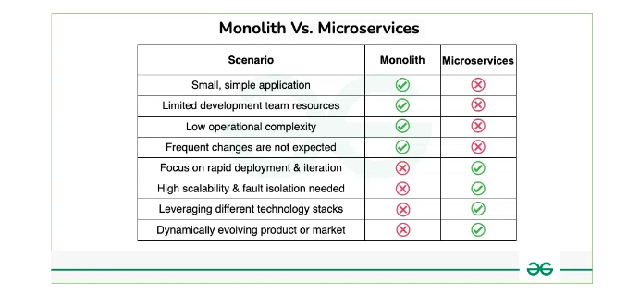

How to decompose an application into services?

* [Decompose by business capability](https://microservices.io/patterns/decomposition/decompose-by-business-capability.html) - define services corresponding to business capabilities
* [Decompose by subdomain](https://microservices.io/patterns/decomposition/decompose-by-subdomain.html) - define services corresponding to DDD subdomains
* [Self-contained Service](https://microservices.io/patterns/decomposition/self-contained-service.html) - design services to handle synchronous requests without waiting for other services to respondnew
* [Service per team](https://microservices.io/patterns/decomposition/service-per-team.html)new
* [Strangler Application](https://microservices.io/patterns/refactoring/strangler-application.html)
* [Anti-corruption layer](https://microservices.io/patterns/refactoring/anti-corruption-layer.html)

Decomposition pattern in microservices- decomposition by subdomain and decomposition by business needs/capabilities.in decomposition by business capabilities services are decomposed according to business requirement as a service but in former we can say microservices are decomposed as subdomain ie one subdomain can have multiple services.

The Strangler Design Pattern is a strategy for migrating from a monolithic architecture to a microservices architecture gradually, without the need for a complete rewrite. It involves incrementally replacing parts of the monolith with microservices until the entire system is decomposed.

**Example Scenario:**

Let's consider a fictional e-commerce platform called "Shopify" that currently operates as a monolithic application. Shopify offers various services such as product browsing, cart management, order processing, and user authentication within a single codebase.

**Implementation of the Strangler Design Pattern:**

1. **Identify a Strangler Route**: Choose a specific feature or functionality within the monolith that you want to migrate to microservices. For example, let's choose "Product Search and Browsing" as the first feature to migrate.
2. **Create a Microservice for the Chosen Feature**: Develop a new microservice dedicated to handling product search and browsing functionality. This microservice will be responsible for serving product data and search queries.
3. **Proxy Requests to the Microservice**: Set up a proxy or gateway in front of the monolith to intercept requests related to product search and browsing. Configure the proxy to route these requests to the newly created microservice.
4. **Incremental Migration**: Over time, gradually move more functionality related to product management from the monolith to the new microservice. This may include features such as product details, category management, and product recommendations.
5. **Monitor and Validate**: Continuously monitor the performance and reliability of the microservice. Validate that the migrated functionality behaves as expected and meets the requirements.
6. **Repeat the Process**: Once the product search and browsing functionality is successfully migrated, identify the next feature to decompose and repeat the process. Examples of features could include user authentication, order processing, or cart management.

**Benefits of the Strangler Design Pattern:**

* **Incremental Migration**: Allows for gradual decomposition of the monolith, reducing the risk associated with a complete rewrite.
* **Minimal Disruption**: Enables continued development and delivery of new features while migrating existing functionality.
* **Isolation of Concerns**: Each microservice is responsible for a specific set of features, promoting better modularity and maintainability.
* **Scalability and Flexibility**: Microservices can be independently scaled and updated, providing better flexibility and resource utilization.

**Conclusion:**

The Strangler Design Pattern provides a structured approach to migrating from a monolithic architecture to a microservices architecture. By incrementally replacing parts of the monolith with microservices, organizations can modernize their systems while minimizing disruption and risk. It's a gradual journey towards a more scalable, resilient, and maintainable architecture.

In Strangler we can also shift load by like initially 10 % and constantly monitor this service and if there is any flaw we can reroute our main monolithic application ang gradually move to microservices.

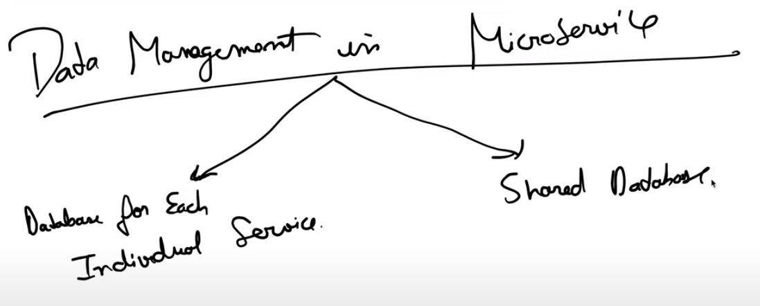

While using a shared database in a microservices architecture might seem convenient at first glance, it often comes with several disadvantages and challenges:

1. **Tight Coupling**: Shared databases can lead to tight coupling between microservices. Changes to the database schema or data model can have cascading effects on multiple services, making it difficult to evolve and scale each service independently.
2. **Limited Autonomy**: Microservices should ideally be autonomous, with each service owning its data and database schema. However, a shared database introduces dependencies between services, limiting their autonomy and making it harder to deploy, test, and version each service independently.
3. **Performance Bottlenecks**: A shared database can become a performance bottleneck, especially in scenarios with high data access rates or complex queries. As the number of services accessing the database increases, contention for database resources can degrade performance and scalability.
4. **Data Integrity and Consistency**: Ensuring data integrity and consistency becomes more challenging with a shared database. Concurrent updates from multiple services can lead to race conditions, data corruption, and inconsistent states, requiring complex synchronization mechanisms to maintain data integrity.
5. **Scaling Limitations**: Scaling a shared database can be challenging. Horizontal scaling might not be feasible due to limitations in the database technology or the complexity of sharding data across multiple nodes. Vertical scaling, on the other hand, can be expensive and may not provide a sustainable solution in the long term.
6. **Security Risks**: A shared database increases the surface area for security vulnerabilities. Access control becomes more complex, and a compromise in one microservice can potentially expose sensitive data across the entire system.
7. **Vendor Lock-in**: Relying on a shared database from a specific vendor can create vendor lock-in, making it difficult to switch to alternative solutions or migrate to the cloud. This can limit flexibility and increase dependency on a single vendor's technology stack.
8. **Operational Complexity**: Managing a shared database introduces additional operational complexity. Backup and recovery procedures, database migrations, and performance tuning need to be coordinated carefully across multiple services, increasing administrative overhead.

In summary, while a shared database might offer short-term convenience, it often leads to long-term challenges in terms of scalability, autonomy, performance, and data management in a microservices architecture. It's generally advisable to follow the microservices principle of bounded contexts and data ownership, where each service has its database tailored to its specific needs.

To demonstrate the use of distributed transactions, we’ll take an example of an e-commerce application that processes online orders and is implemented with microservice architecture.

There is a microservice to create the orders, one that processes the payment, another that updates the inventory and the last one that delivers the order.

Each of these microservices performs a local transaction to implement the individual functionalities:

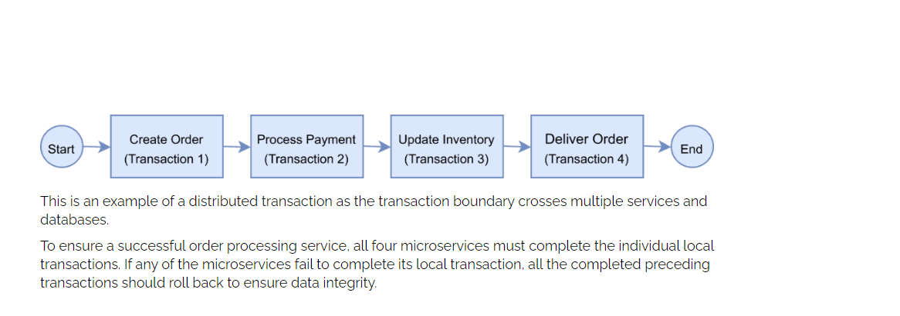

## Challenges of Distributed Transaction

In the previous section, we provided a real-life example of a distributed transaction. Distributed transactions in a microservice architecture pose two key challenges.

**The first challenge is maintaining ACID.**To ensure the correctness of a transaction, it must be Atomic, Consistent, Isolated and Durable (ACID). The atomicity ensures that all or none of the steps of a transaction should complete. Consistency takes data from one valid state to another valid state. Isolation guarantees that concurrent transactions should produce the same result that sequentially transactions would have produced. Lastly, durability means that committed transactions remain committed irrespective of any type of system failure. **In a distributed transaction scenario, as the transaction spans several services, ensuring ACID always remains key.**

**The second challenge is managing the transaction isolation level.**It specifies the amount of data that is visible in a transaction when the other services access the same data simultaneously. In other words, if one object in one of the microservices is persisted in the database while another request reads the data, should the service return the old or new data?

## Understanding Two-Phase Commit

The Two-Phase Commit protocol (2PC) is **a widely used pattern to implement distributed transactions.** We can use this pattern in a microservice architecture to implement distributed transactions.

In a two-phase commit protocol, there is a coordinator component that is responsible for controlling the transaction and contains the logic to manage the transaction.

The other component is the participating nodes (e.g., the microservices) that run their local transactions:

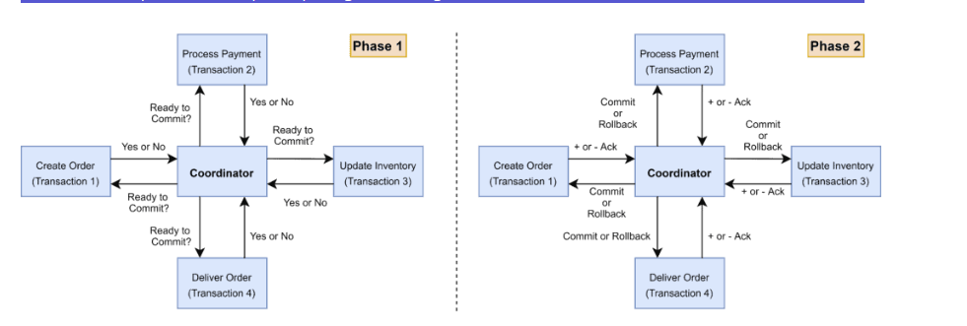

As the name indicates, the two-phase commit protocol runs a distributed transaction in two phases:

1. **Prepare Phase** – The coordinator asks the participating nodes whether they are ready to commit the transaction. The participants returned with a *yes* or *no*.
2. **Commit Phase** – If all the participating nodes respond affirmatively in phase 1, the coordinator asks all of them to commit. If at least one node returns negative, the coordinator asks all participants to roll back their local transactions.

## Problems With 2PC

Although 2PC is useful to implement a distributed transaction, it has the following shortcomings:

* The **onus of the transaction is on the coordinator node**, and it can become the single point of failure.
* All other services need to wait until the slowest service finishes its confirmation. So, the overall performance of the transaction is bound by the slowest service.
* The two-phase commit protocol is**slow by design due to the chattiness and dependency on the coordinator.** So, it can lead to scalability and performance issues in a microservice-based architecture involving multiple services.
* Two-phase commit protocol is **not supported in NoSQL databases.** Therefore, in a microservice architecture where one or more services use NoSQL databases, we can’t apply a two-phase commit.

## Introduction to Saga

### 7.1. What Is Saga Architecture Pattern?

The Saga architecture pattern **provides transaction management using a sequence of local transactions.**

A local transaction is the unit of work performed by a Saga participant. Every operation that is part of the Saga can be rolled back by a compensating transaction. Further, the Saga pattern guarantees that either all operations complete successfully or the corresponding compensation transactions are run to undo the work previously completed.

In the Saga pattern, **a compensating transaction must be idempotent and retryable.** These two principles ensure that we can manage transactions without any manual intervention.

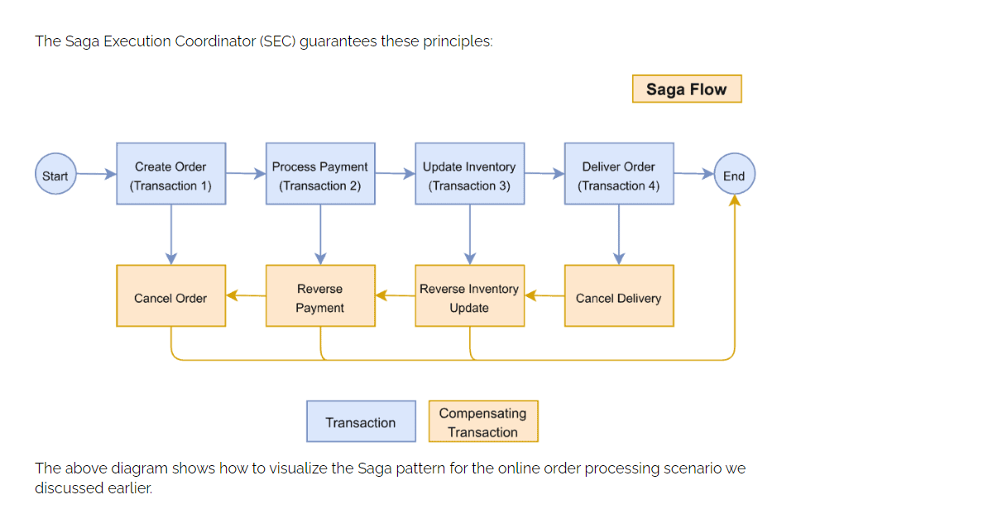

### The Saga Execution Coordinator

The **Saga Execution Coordinator is the central component to implement a Saga flow.** It contains a Saga log that captures the sequence of events of a distributed transaction.

For any failure, the SEC component inspects the Saga log to identify the impacted components and the sequence in which the compensating transactions should run.

For any failure in the SEC component, it can read the Saga log once it’s coming back up.

It can then identify the transactions successfully rolled back, which ones are pending, and can take appropriate actions:

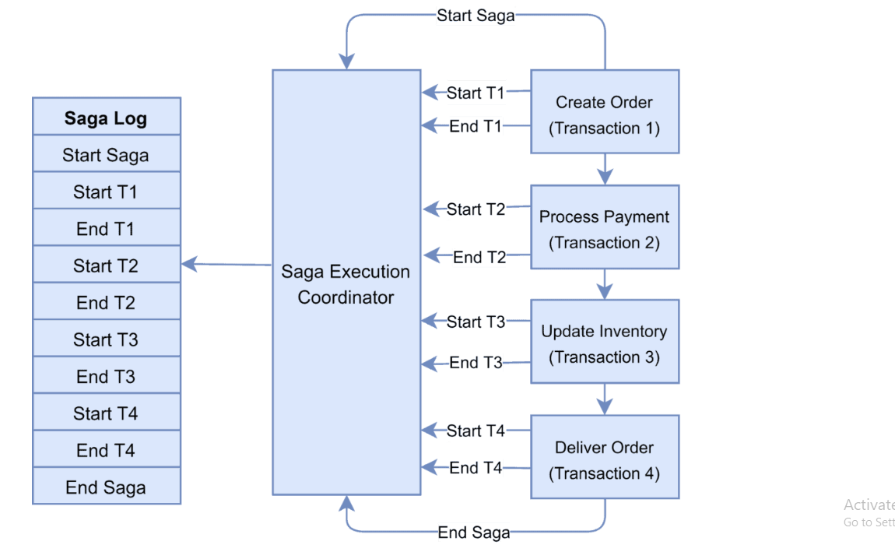

### Implementing Saga Choreography Pattern

In the Saga Choreography pattern, **each microservice that is part of the transaction publishes an event that is processed by the next microservice.**

To use this pattern, we need to decide if the microservice will be part of the Saga. Accordingly, the microservice needs to use the appropriate framework to implement Saga. In this pattern, the Saga Execution Coordinator is either embedded within the microservice or can be a standalone component.

In the Saga, choreography flow is successful if all the microservices complete their local transaction, and none of the microservices reported any failure.

The following diagram demonstrates the successful Saga flow for the online order processing application:

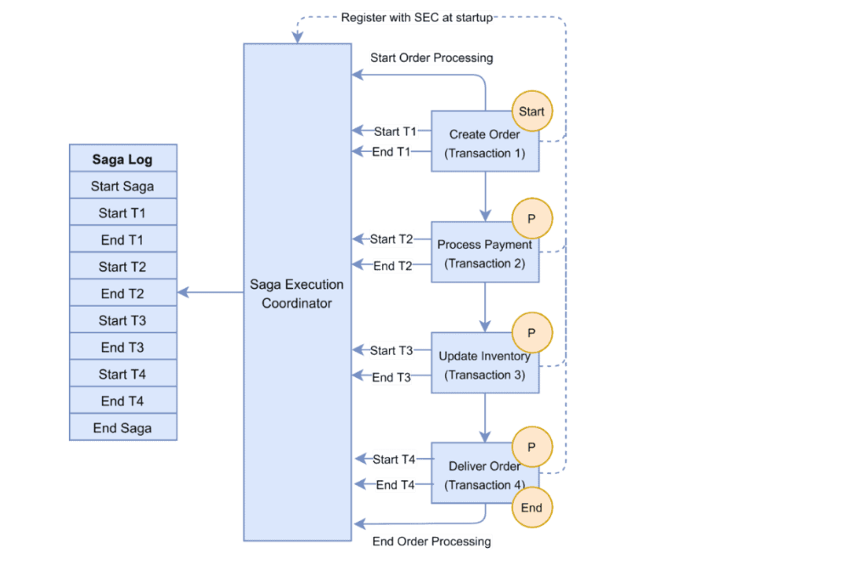

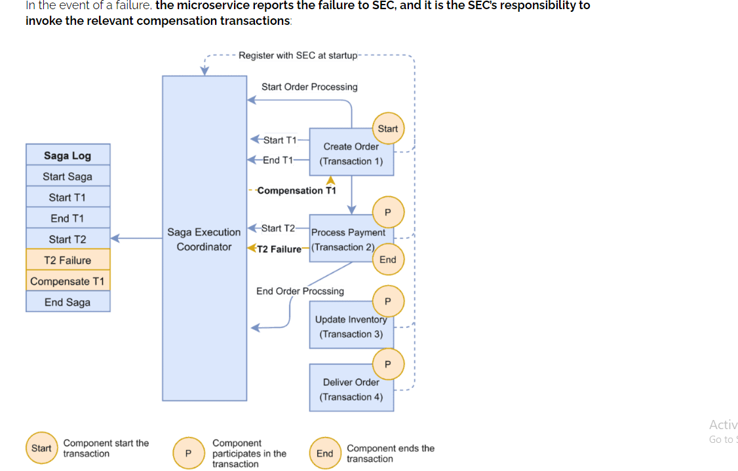

In this example, the Payment microservice reports a failure, and the SEC invokes the compensating transaction to unblock the seat. If the call to the compensating transaction fails, it is the SEC’s responsibility to retry it until it is successfully completed. Recall that in Saga, a compensating transaction must be *idempotent* and *retryable*.

The Choreography pattern **works for greenfield microservice application development.** Also, this pattern is suitable when there are fewer participants in the transaction.

Here are a few frameworks available to implement the choreography pattern:

* [**Axon Saga**](https://docs.axoniq.io/reference-guide/v/3.1/part-ii-domain-logic/sagas) – a lightweight framework and widely used with Spring Boot-based microservices
* [**Eclipse MicroProfile LRA**](https://github.com/eclipse/microprofile-lra) – implementation of distributed transactions in Saga for HTTP transport based on REST principles
* [**Eventuate Tram Saga**](https://eventuate.io/docs/manual/eventuate-tram/latest/getting-started-eventuate-tram-sagas.html) – Saga orchestration framework for Spring Boot and Micronaut-based microservices
* [**Seata**](https://www.seata.io/docs/dev/mode/saga-mode/) – open-source distributed transaction framework with high-performance and easy-to-use distributed transaction services

**7.4. Implementing Saga Orchestration Pattern**

In the Orchestration pattern, **a single orchestrator is responsible for managing the overall transaction status.**

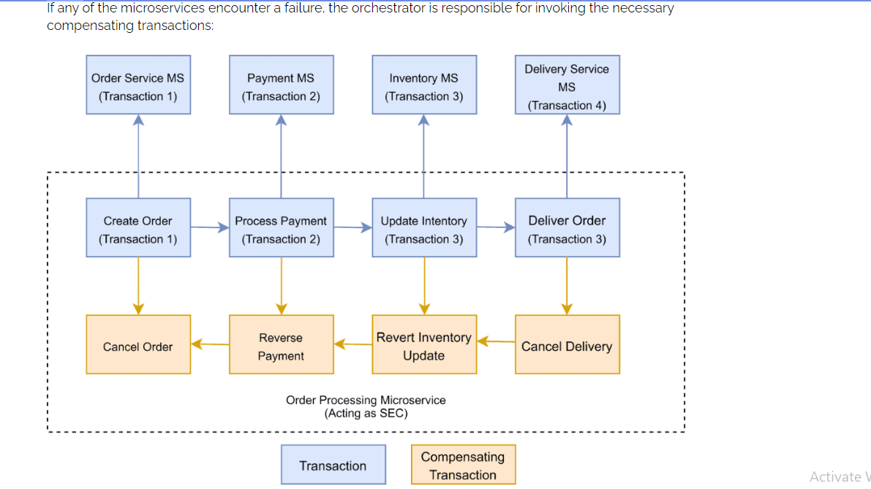

The Saga orchestration pattern is **useful for brownfield microservice application development architecture.** In other words, this pattern works when we already have a set of microservices and would like to implement the Saga pattern in the application. We need to define the appropriate compensating transactions to proceed with this pattern.

Here are a few frameworks available to implement the orchestrator pattern:

* [**Camunda**](https://camunda.com/) is a Java-based framework that supports Business Process Model and Notation (BPMN) standard for workflow and process automation.
* [**Apache Camel**](https://camel.apache.org/components/latest/eips/saga-eip.html) provides the implementation for Saga Enterprise Integration Pattern (EIP).

## Conclusion

In this article, we discussed the Saga architecture pattern to implement distributed transactions in a microservice-based application.

We first introduced the challenges of these implementations.

We then explored the two-phase commit protocol, a popular alternative of Saga, and examined its limitation to implement distributed transactions in microservice-based applications.

Lastly, we discussed the Saga architecture pattern, how it works and the two main approaches to implementing the Saga pattern in microservice-based applications.

The Command Query Responsibility Segregation (CQRS) design pattern is a powerful architectural pattern used in microservices to separate read and write operations. This separation allows for better scalability, maintainability, and performance optimization.

### Key Concepts of CQRS

1. **Commands**: Operations that change the state of the system (write operations). Commands are typically handled synchronously and result in side effects, such as updating a database.
2. **Queries**: Operations that retrieve data without modifying the state of the system (read operations). Queries are often optimized for performance and can be handled asynchronously or synchronously.
3. **Segregation**: The core idea is to segregate the command (write) and query (read) operations into different models. This means having separate interfaces, models, and data stores for commands and queries.

### Benefits of CQRS

* **Scalability**: Read and write operations can be scaled independently. This is useful in applications with a high read-to-write ratio.
* **Performance Optimization**: Different data stores can be used for read and write operations, allowing each to be optimized for its specific access patterns.
* **Maintainability**: By separating concerns, the system becomes easier to understand and maintain.
* **Flexibility**: Enables implementing different data consistency models and eventual consistency for reads.

### CQRS in Microservices

In a microservices architecture, CQRS can help manage the complexity by clearly defining the boundaries between services and their responsibilities.

### Example Scenario

Consider an e-commerce platform where customers can place orders and browse product catalogs.

#### Commands (Write Operations)

* **Place Order Service**: Handles creating new orders. It processes commands like **PlaceOrderCommand**, which includes details such as customer information, products, and payment details.

#### Queries (Read Operations)

* **Order Query Service**: Retrieves order details. It handles queries like **GetOrderDetailsQuery**, returning information about specific orders.

### Implementation Steps

1. **Define Command and Query Models**:
   * **Command Model**: Includes entities and DTOs for write operations. For example, **Order** and **PlaceOrderCommand**.
   * **Query Model**: Includes entities and DTOs for read operations. For example, **OrderDetails** and **GetOrderDetailsQuery**.
2. **Separate Data Stores**:
   * **Write Store**: Used for transactional consistency, often a relational database.
   * **Read Store**: Optimized for quick access, possibly using a NoSQL database or in-memory cache.
3. **Implement Command Handlers**:
   * Handle command processing logic, validate input, and update the write store. Use event sourcing to propagate changes if needed.
4. **Implement Query Handlers**:
   * Handle data retrieval logic from the read store. Optimize for fast data access and minimal latency.
5. **Synchronize Data**:
   * Use event-driven mechanisms to synchronize data between the write and read stores. For example, when an order is placed, an event is published that updates the read store.

In CQRS the main idea is to separate the read and write operations as in db per service there is difficulty in using cross joins so to resolve this issue we separate write operation by allowing the service to write at its own db and no other service can perform any update operation in other service db and one other database is maintained with complete data from all the db in synchronized form and read opertions are pulled from their.

**SCALE from 0 to 1 million users**

* 1. Separation of application and db server.
  2. Load balancer
  3. 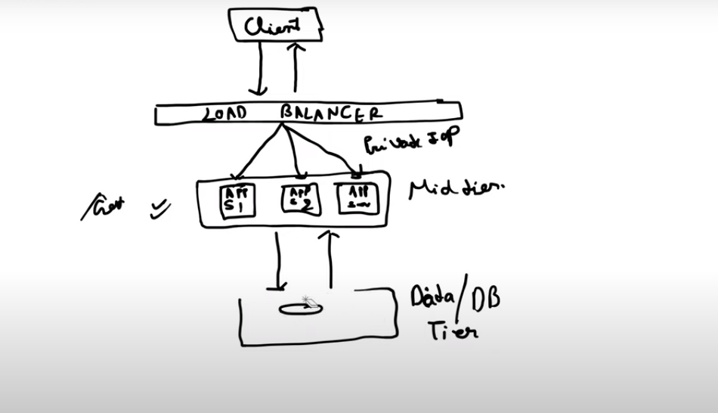
  4. Db replication- In this we use master slave architecture in which all the write operations are performed on master db and all the read operation are performed from slaves and there can be multiple slave and in case master db fails then any of the slave can become the master and the sytem db will stay up.
  5. Caching – cache hit is when data is available in cache and cache miss when it doesn’t found in cache.it uses concept of time to live that is the time for which the data will be present in cache.
  6. CDN Servers-
  7. 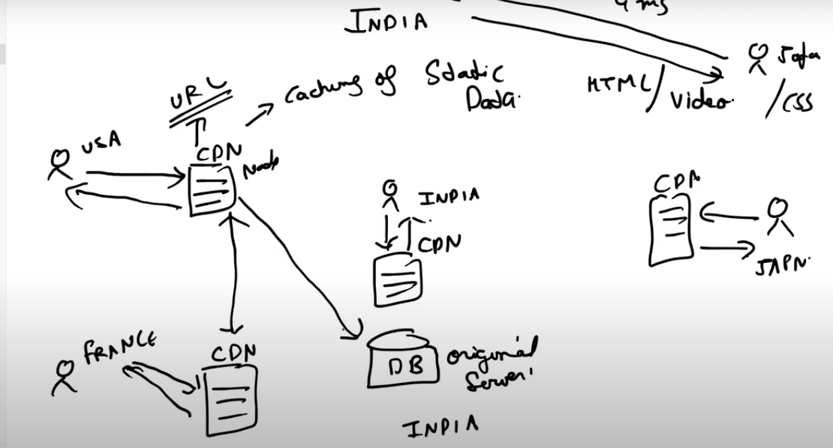

In cdn static data are stored in cdn servers or cdn nodes and cdn does caching also and when user request for any data then it first checks whether my data is in cdn server or not if not then it will go its nearest cdn server and if data not found there also then it goes to the original server and then does caching also.it also take care of ddos and if suspects something suspicious then it return back from there and it helps in reducing the load from the server and improves performance.

* 1. Multiple data centers

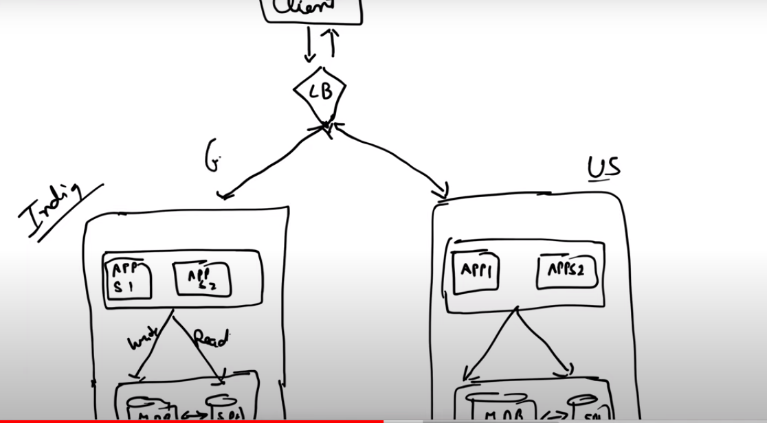

9.Messaging queue.

10. Database scaling – sharding – horizontal and vertical in horizontale table id divided into 2 tables and data is divided row wise lets say table has 1000 records then in 1st shard it will store upto 500 rows and in 2nd shard it will store from 501 to 1000 records and in vertical sharding we divide table into lets say 2 tables and store half column in one table and other half in other on the basis of requirement.

But there is drawback of sharding 1st is there will be difficulty in joins for that we need to denormalize the tables and say you are sharding on the basis of alphabets and name and there are high number of users with name a then you need to shard that table again and there can be multiple level of sharding that increases complexity.

Hashing

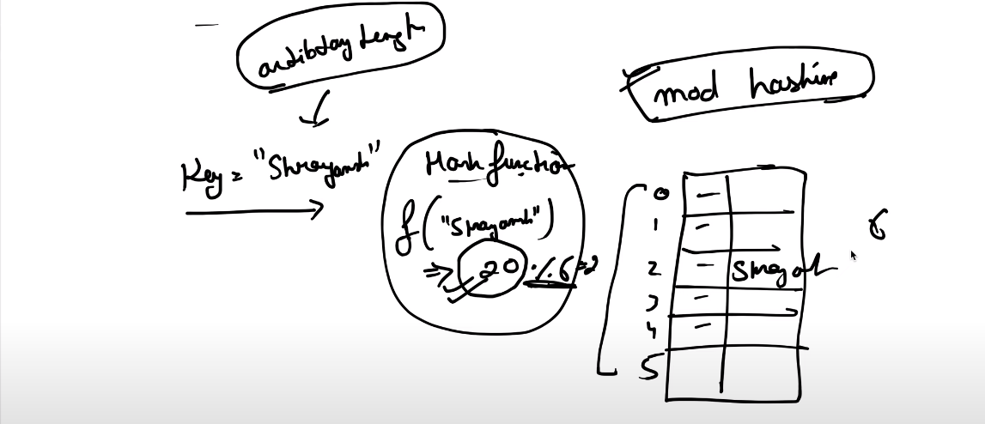

## What is a Hash Function?

A **hash function** is a function that takes an input (or ‘message’) and returns a fixed-size string of bytes. The output, typically a number, is called the **hash code** or**hash value**. The main purpose of a hash function is to efficiently map data of arbitrary size to fixed-size values, which are often used as indexes in hash tables.

In mod hashing lets say size of our hash table is 6 so the key will be modulous of size so that remainder will always lie in the length of the table and data corresponding to that key is stored on that index.

Problems with hashing

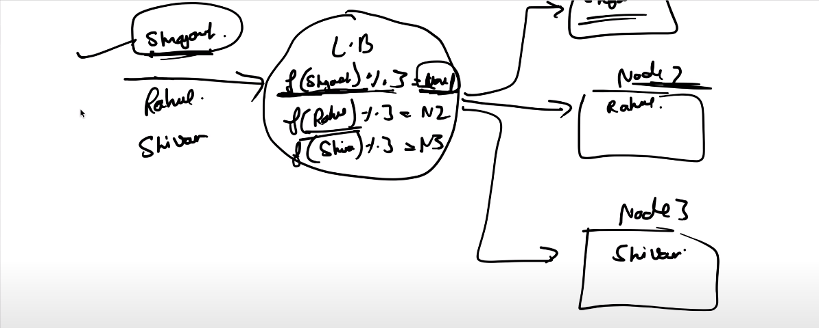

Suppose load balancer is using f(input)%3 then it will store data accordingly on either node1,node2 or node3 . in case app server is increased to 4 . then there might be possibility that for the same value stored at node it will find on node 2 because now app servers are increased to 4. So in that case we need to do rebalancing ie we need to balance the data from node1 to node2.this is the limitation of fixed size hashing in case of load balancer and same in case of horizontal db sharding.

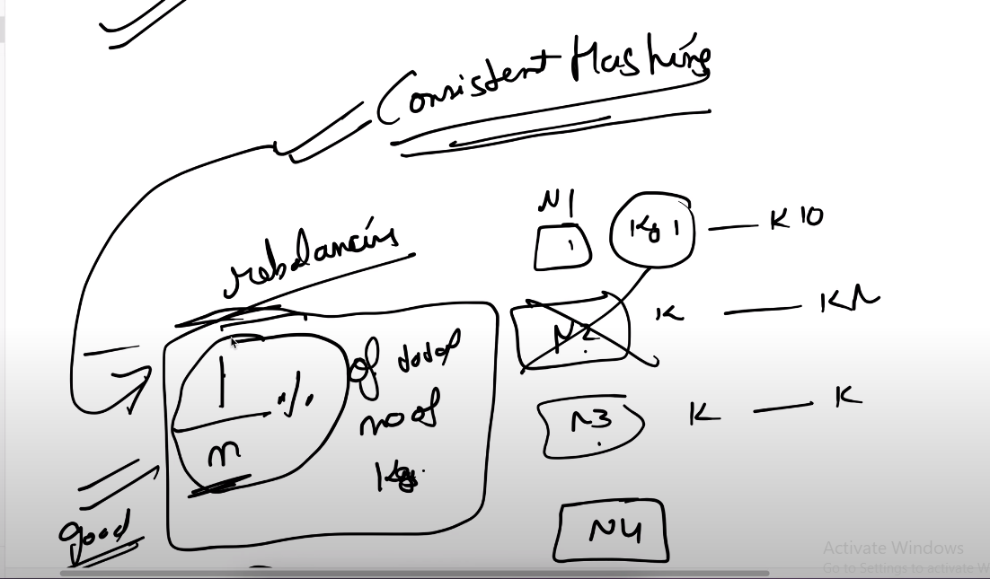

In case of consistent hashing if any new node is added or some node are deleted than there must be on avg 1/n% no of rebalancing required that is considered good. N is the number of nodes.

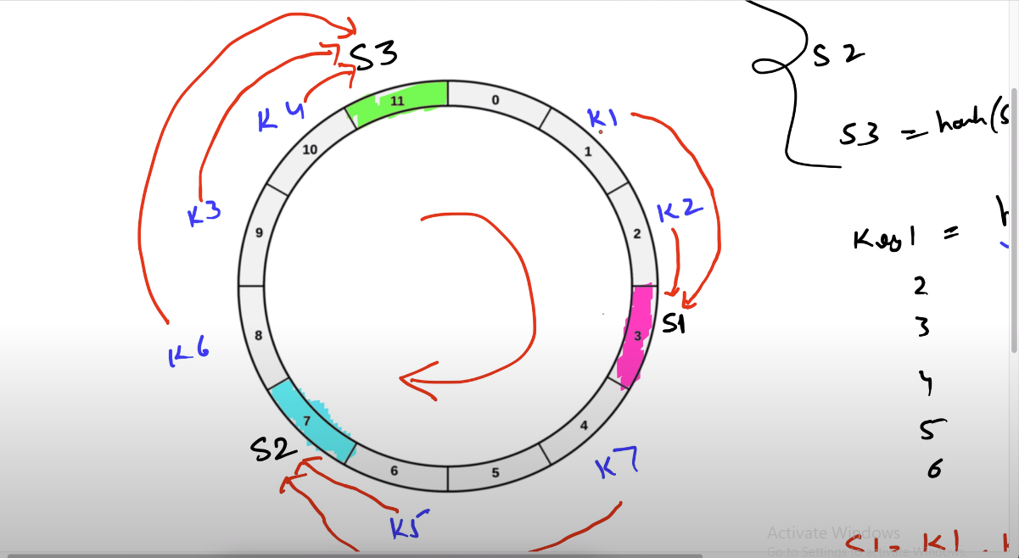

Consistent hashing working-

We first consider a virtual key and hash of servers using length of virtual ring for and place the servers on the appropriate index and when the request comes hash of key using using length of circular key is find and for instance servers and keys placed at given index so now it will move in circular manner in clockwise direction and the values are processed by the servers which are encountered first and in this ways values are processed.

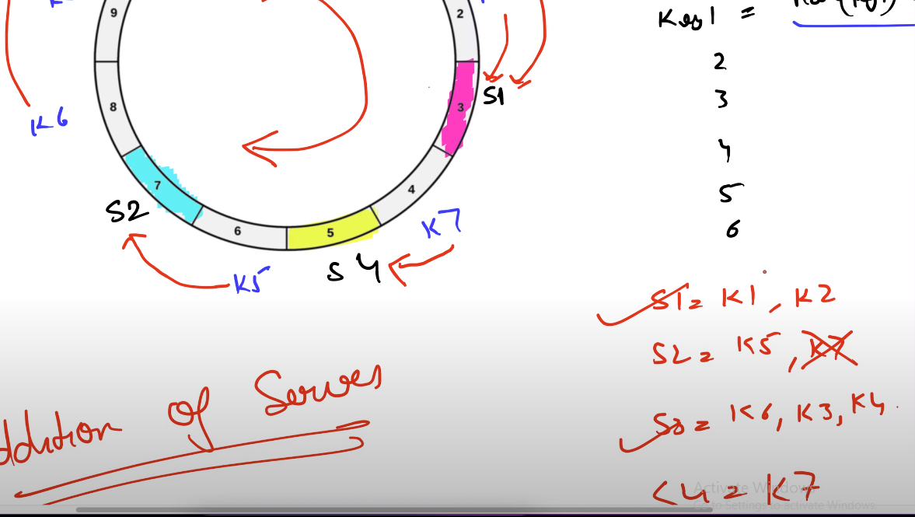

Now for instance we add another server and there is only one change for our case that it will need to rebalance only k7 key previously handled by s2 server and currently handled by s4 server so the no of rebalancing decreased.

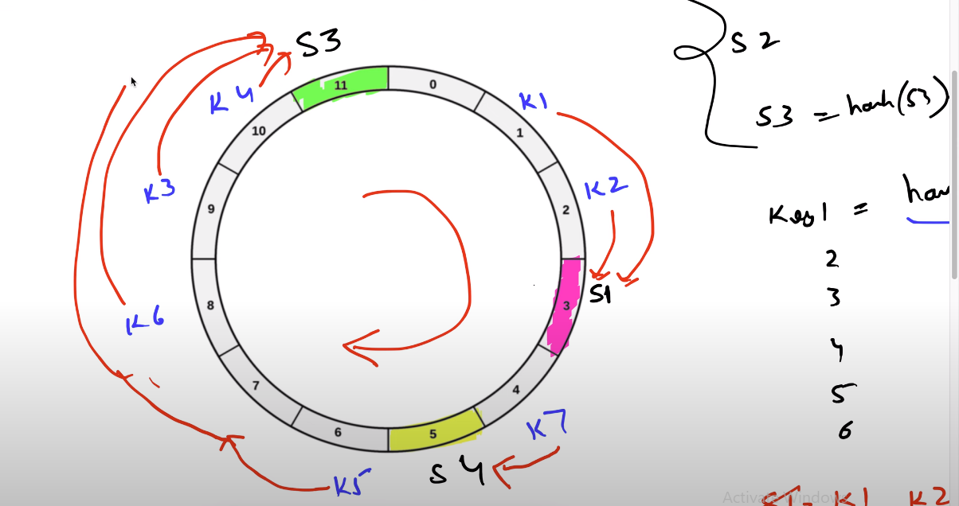

Suppose server s3 is removed than k5 will be handled by s3

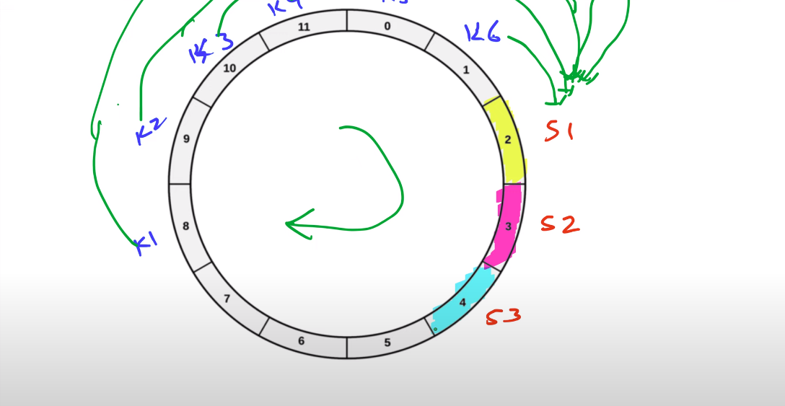

Disadvantage of consistent hashing is what if servers are not equally sepearated like in above case so the all traffic will be routed to s1.

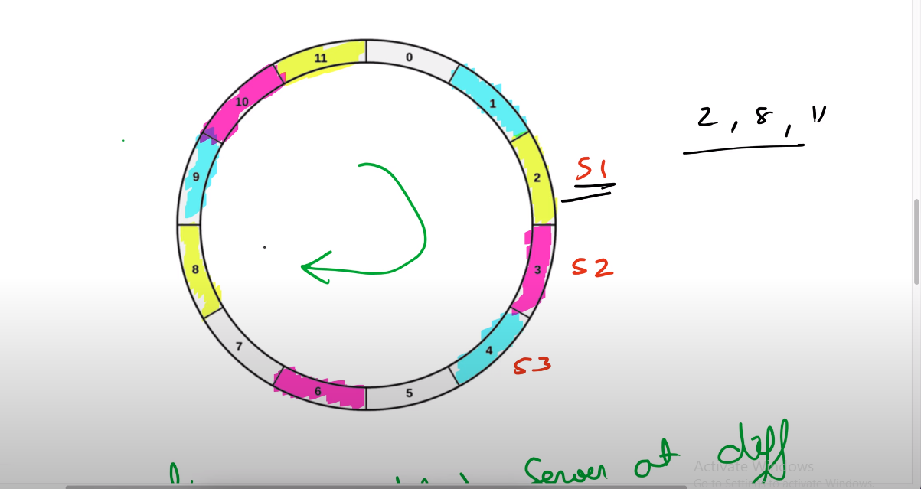

Solution is creating virtual objects and placing servers at one or more location randomly like above.



No of replicas till I achieve i/n% of rebalancing till then we need to replicate.

Hashing involves using a hash function to produce a pseudo-random number. This number is then divided by the size of the available memory space, resulting in the transformation of the random identifier into a position within the given memory space. This process can be conceptually represented as follows:

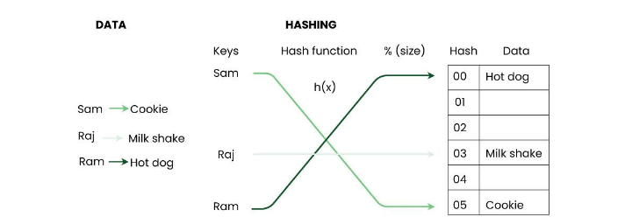

Consistent hashing is a technique used in computer systems to distribute keys (e.g., cache keys) uniformly across a cluster of nodes (e.g., cache servers). The goal is to minimize the number of keys that need to be moved when nodes are added or removed from the cluster, thus reducing the impact of these changes on the overall system.

Back of envelop consideration is the drive over decision for system design ie whether we gonna need a load balancer or not basically designing system with considering system constraints.

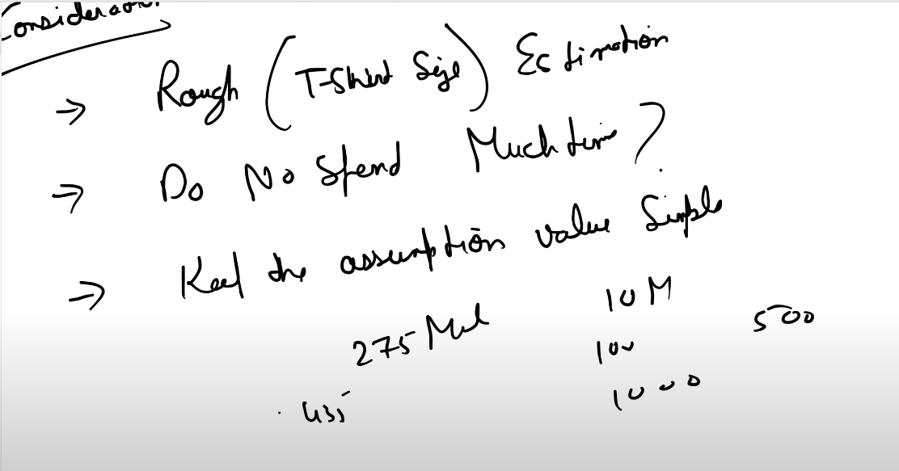

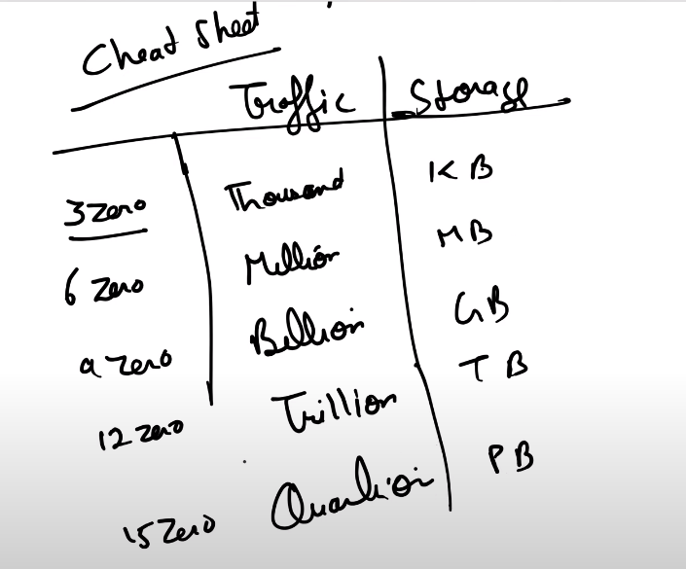

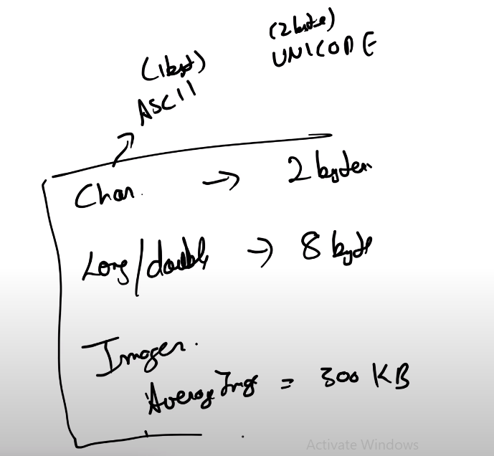

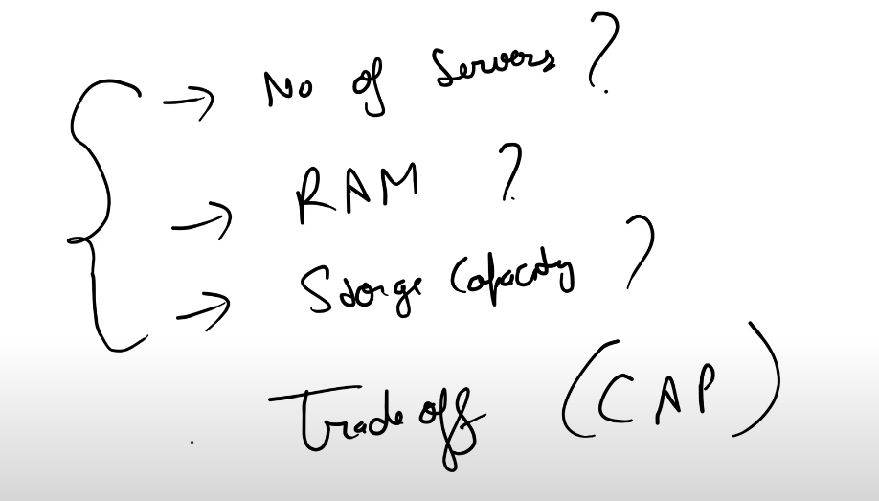

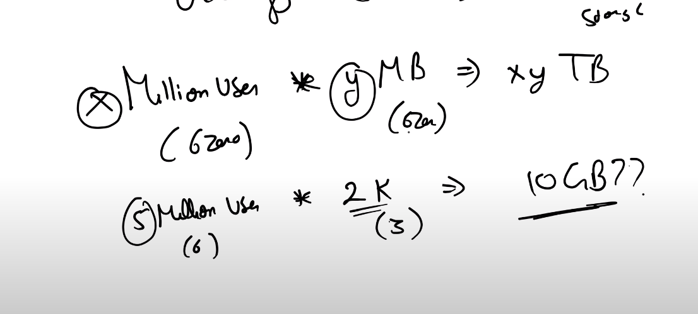

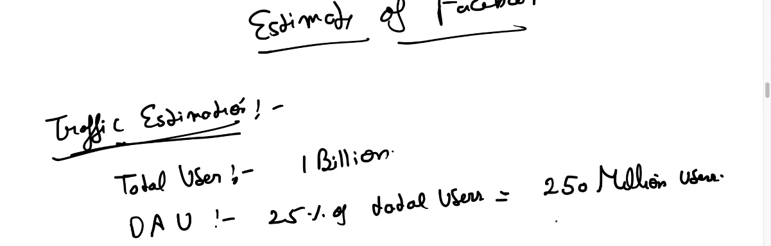

Dau-daily active users

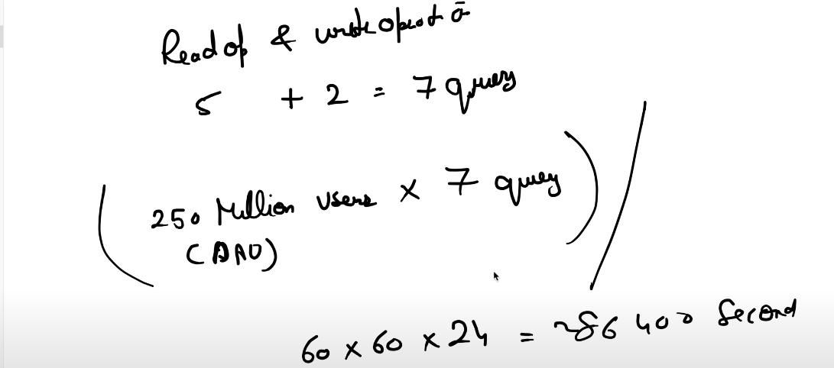

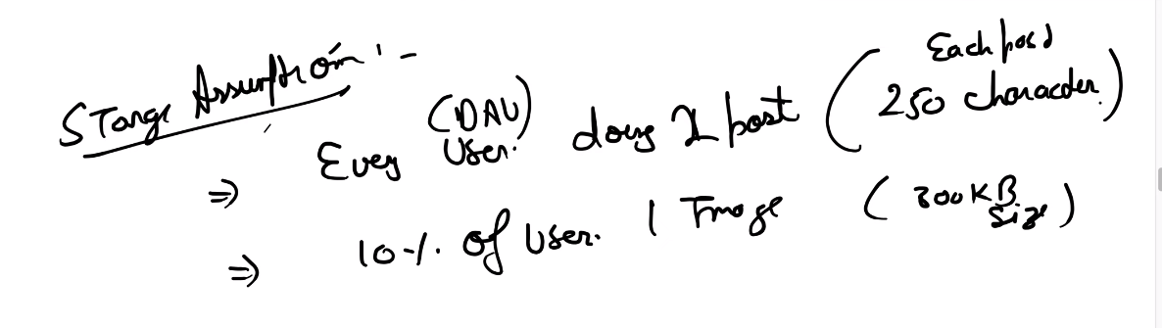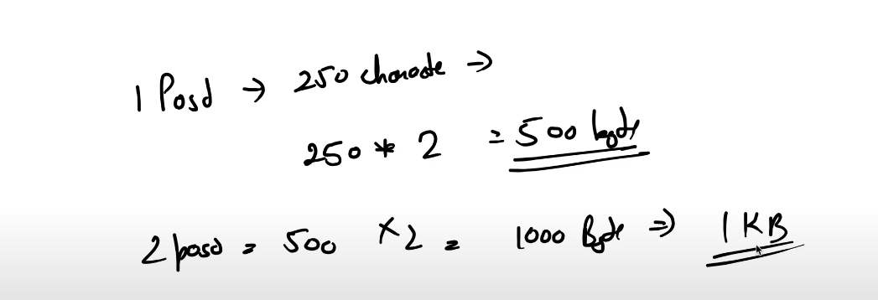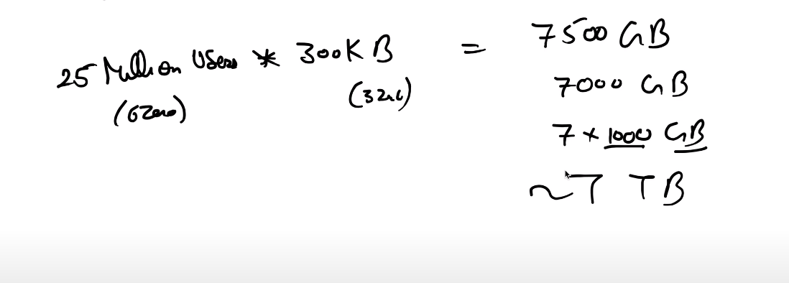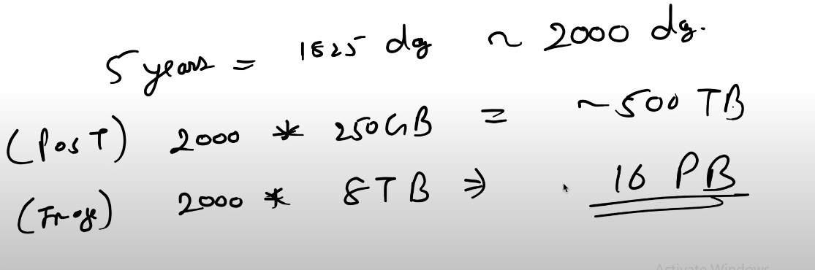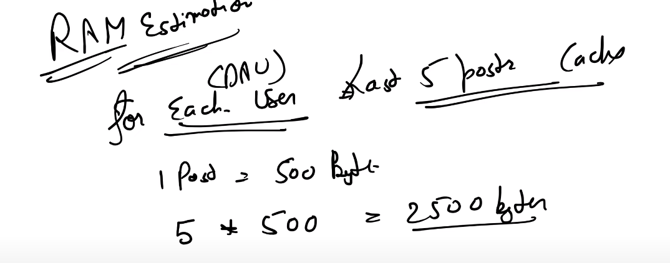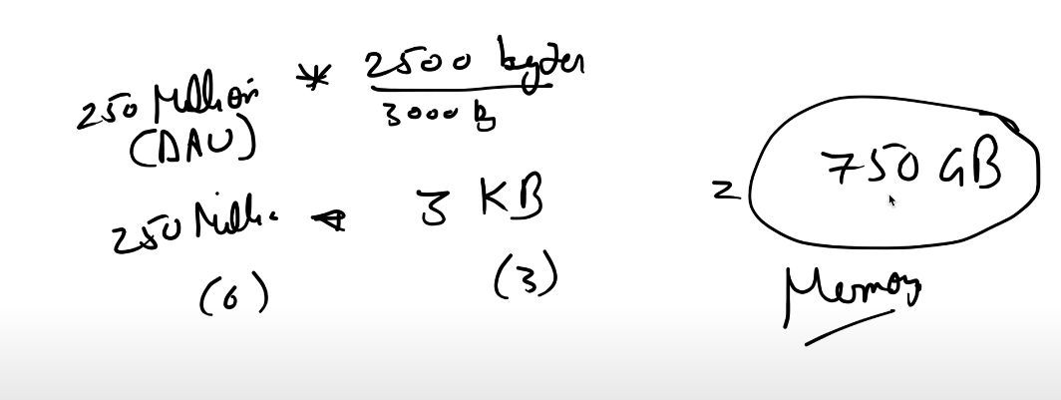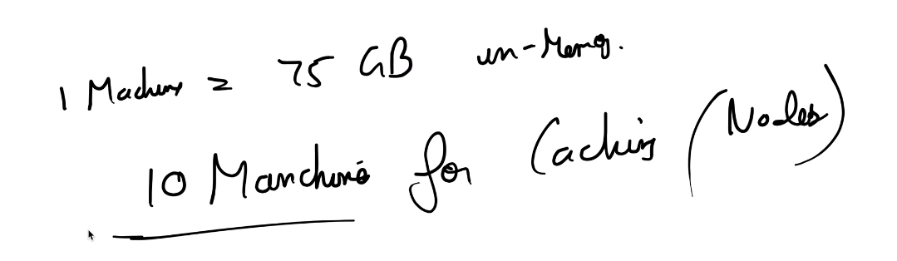

SQL – structure – data is stored in structured format in tables of rows and columns and there may be relationship between tables.

nature – in most cases all the tables for ex used for storing user based information is stored in a single server instead of multiple.

Scalability – vertical ad horizontal in case of horizontal scaling there may be case when data or related tables are present in different servers.

Property- ACID consistent properties.

NOSQL – structure

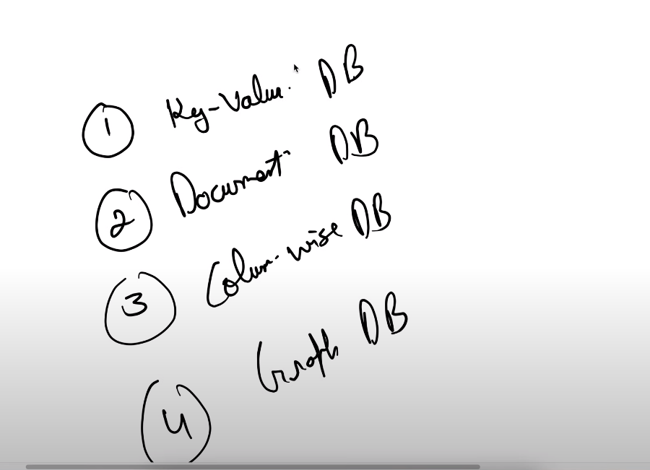

Key-value

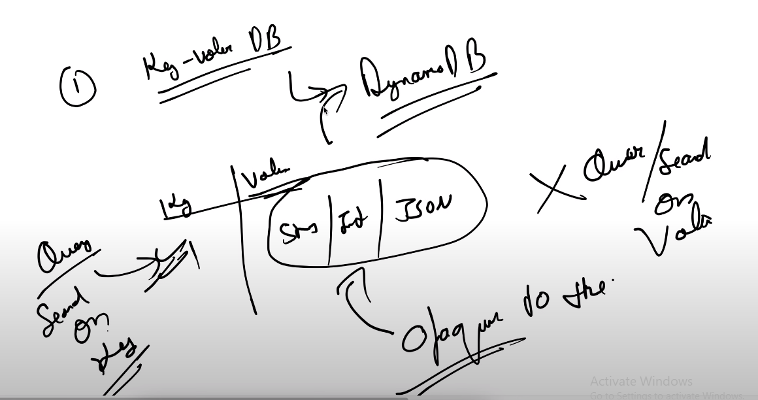

In this we can only search or query on key only and not in value.

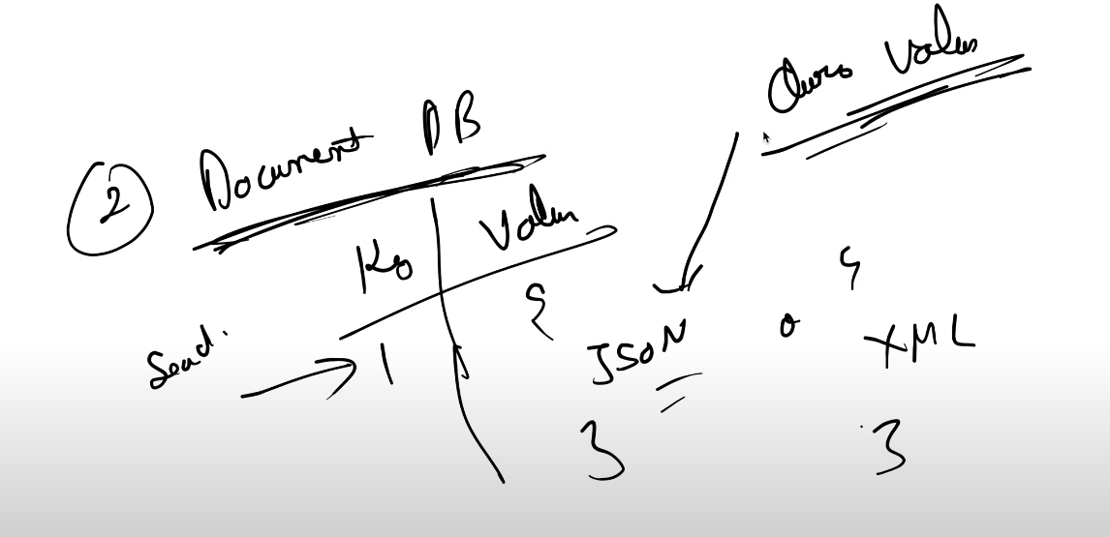

Difference between key value and document is that along with key we can query on value also. Eg MongoDB.

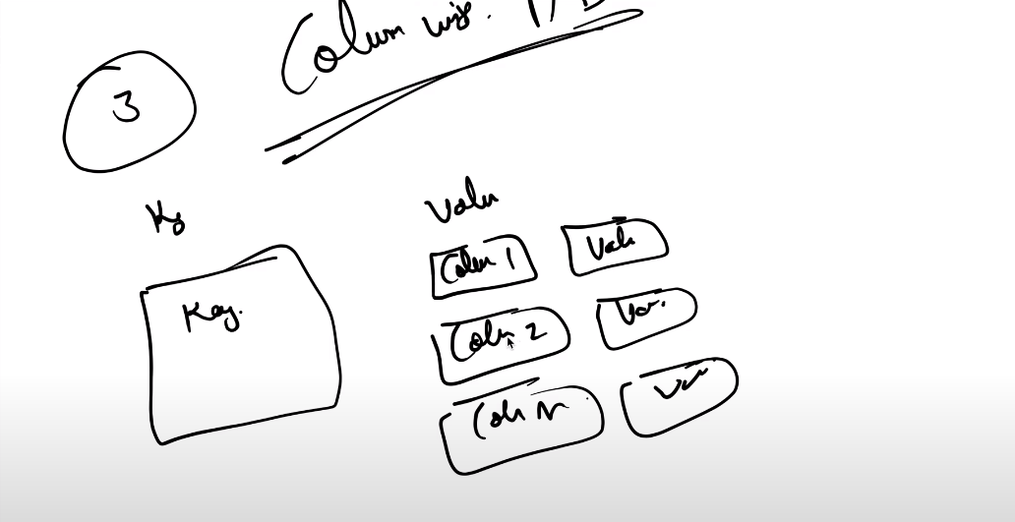

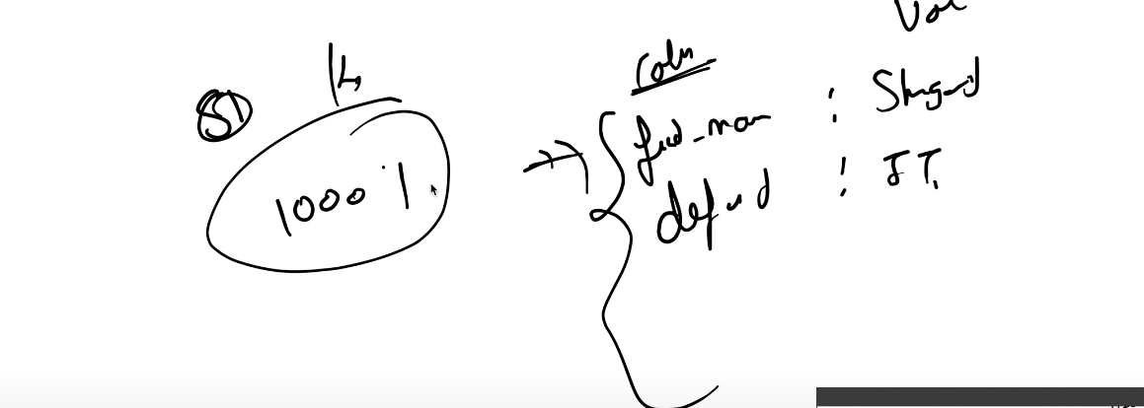

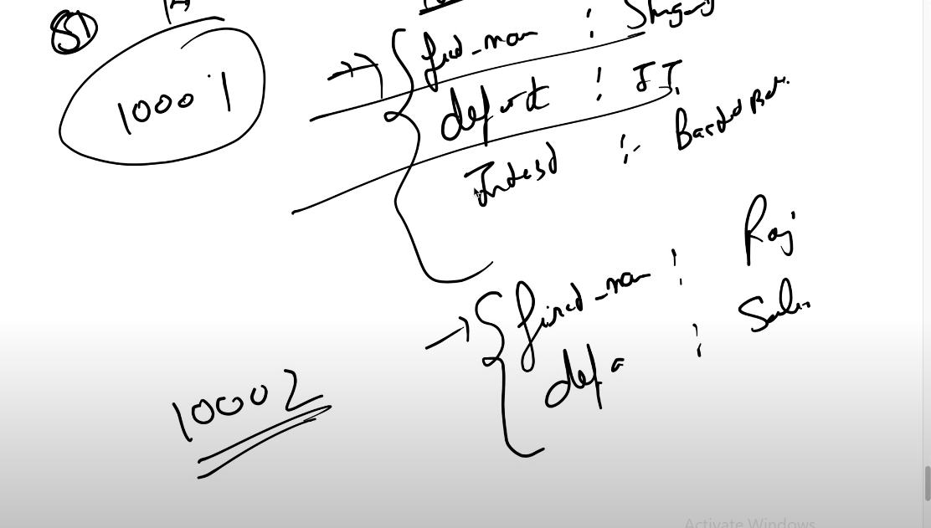

In this no of columns can be dynamic.

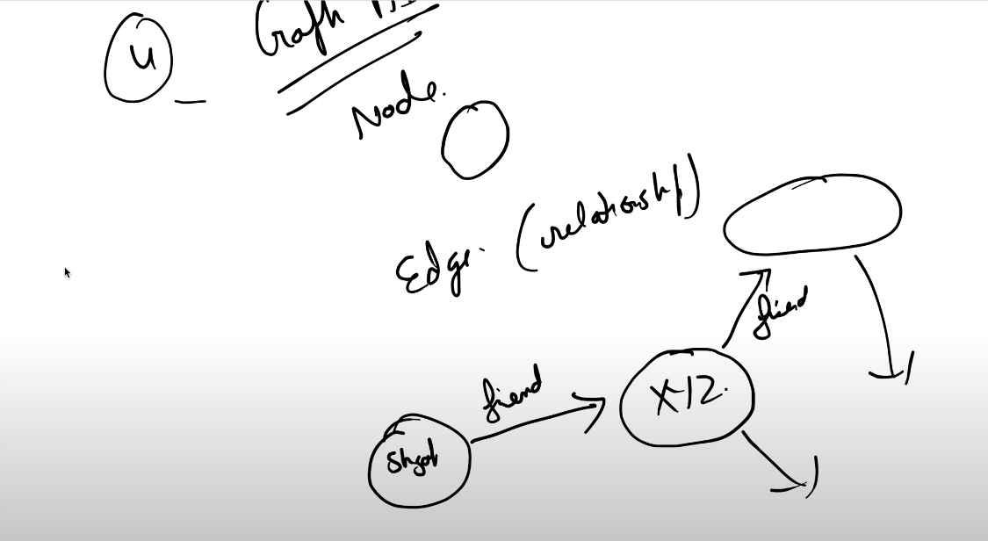

In case of mysql there is also relationship between parent and child and difference between mysql and graphQL Is that mysql scans full row but there is direct connection in graphQL and it is very fast as compared to MySQL and have direct relationship use case are social networking profile and recommendation engine.

Nature of nosql – distributed in nature ie data can be stored in different nodes.

Scalability – horizontal

Property – BASE

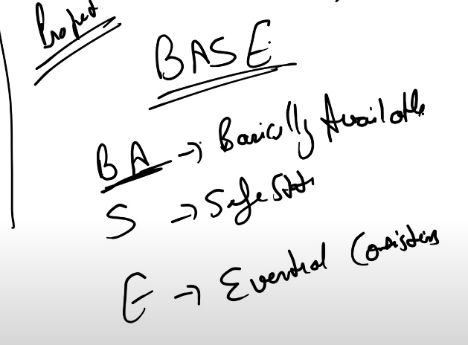

Safe State means that if any node has update data as they are in sync together then stale nodes will update their datas to the most recent data.

Eventual consistency is there can be case when you can get stale data when querying and if you keep on querying then after sometime you can get update data as the nodes are in sync with each other.

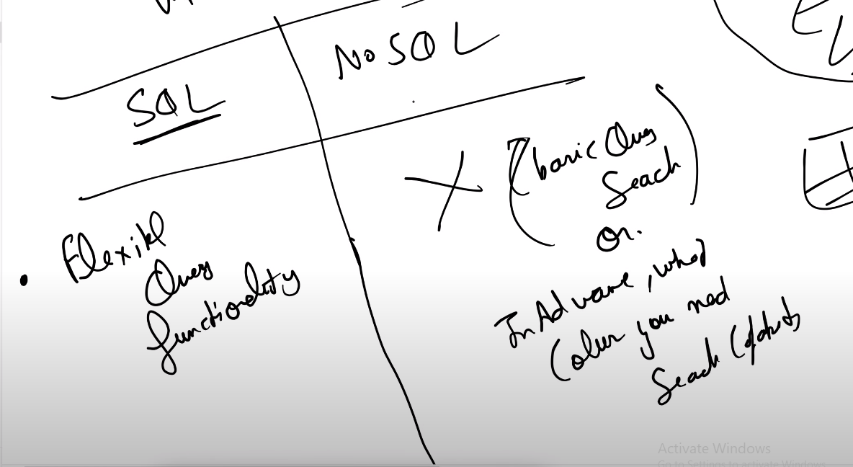

Can join on multiple tables in sql but there is basic query in nosql

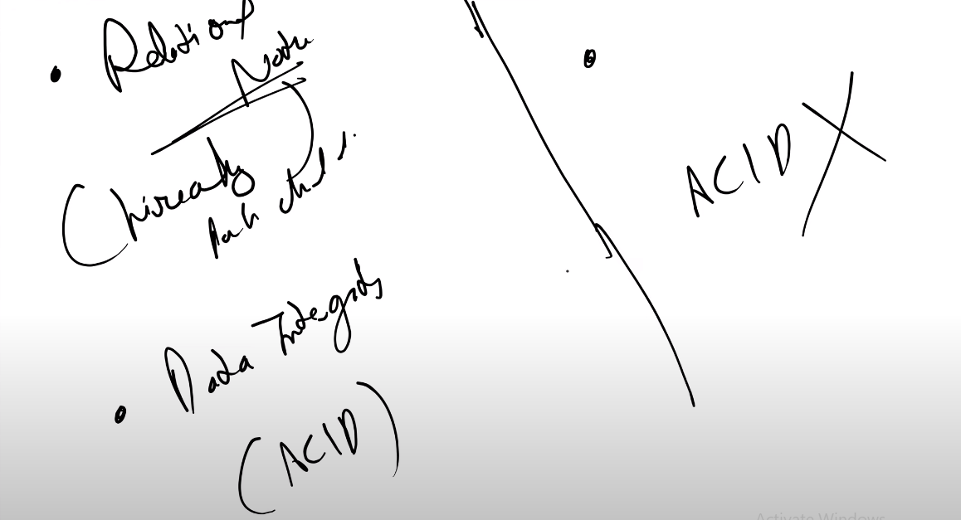

When you can’t loose single transaction and where you need consistency then there is no way nosql can provide this.

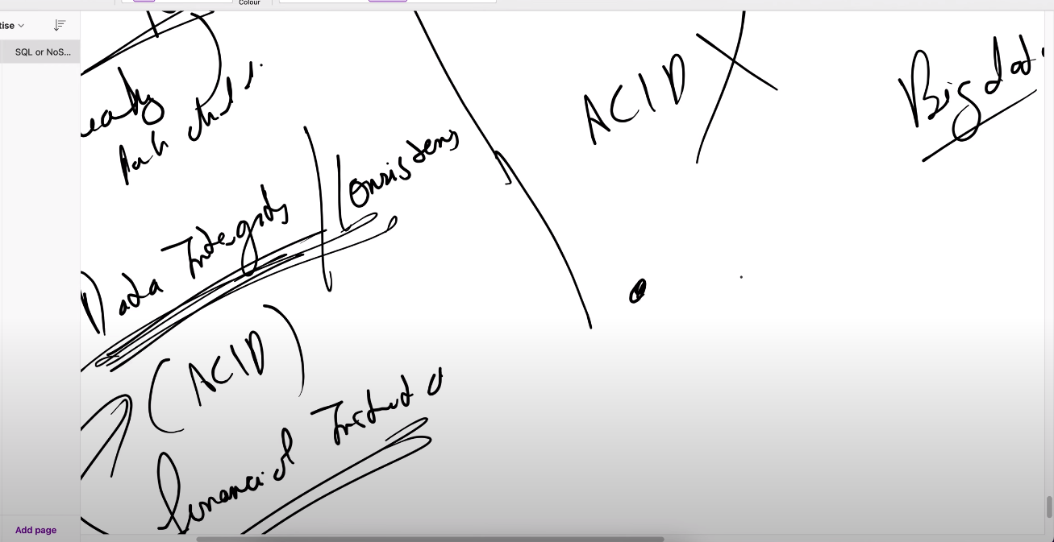



# How does Kafka work?

Now that you have a basic understanding of the Kafka components, let’s see how they work together to provide a distributed streaming platform.

* **When a producer** wants to send an event to a topic, it first connects to a broker and asks for the metadata of the topic. The metadata contains information about the partitions of the topic, such as their leader and follower brokers, their offsets (positions), and their availability. The producer then chooses a partition to send the event to, based on some partitioning strategy (such as round-robin, hash-based, or custom). The producer then sends the event to the leader broker of the partition, which appends it to the end of the partition and assigns it an offset (a unique identifier). The leader broker then replicates the event to the follower brokers of the partition, which also append it to their partitions. The producer receives an acknowledgment from the leader broker when the event is successfully stored on all the replicas.
* **When a consumer**wants to read an event from a topic, it first connects to a broker and subscribes to the topic. The broker assigns the consumer to a consumer group, which is a logical grouping of consumers that share the same topic subscription. The broker also assigns each partition of the topic to one consumer in the group, based on some assignment strategy (such as range-based or round-robin). The consumer then fetches the events from its assigned partitions from the leader brokers. The consumer also maintains its current offset for each partition, which indicates how far it has consumed the events. The consumer periodically commits its offsets to the broker, which allows it to resume from where it left off in case of failures or rebalances.
* **When a new broker** joins or leaves the cluster, or when a broker fails or recovers, Kafka automatically triggers a rebalance process. This process involves reassigning the partitions and their replicas among the available brokers, and reassigning the partitions and their consumers among the consumer groups. The rebalance process ensures that the cluster remains balanced and resilient, and that the consumers can continue to consume the events without interruption.

# Benefits of Kafka

* **High throughput**: Kafka can handle millions of events per second, with low latency and high efficiency
* **Scalability**: Kafka can scale horizontally by adding more brokers to the cluster, without requiring any downtime or data loss
* **Reliability**: Kafka can tolerate failures of some brokers or partitions, without compromising the availability or consistency of the data
* **Durability**: Kafka can store events on disk for a configurable retention period, which can be hours, days, weeks, or even forever. This allows you to replay or reprocess the events if needed
* **Flexibility**: Kafka can support various types of events, such as logs, metrics, transactions, notifications, etc. Kafka can also integrate with various types of producers and consumers, such as Java, Python, Ruby, etc. Kafka can also connect with other systems, such as databases, Hadoop, Spark, etc. using connectors or APIs
* **Real-time**: Kafka can enable real-time processing of events, such as streaming analytics, anomaly detection, fraud prevention, etc.

# Conclusion

Kafka architecture is a powerful and flexible platform that can handle any kind of data stream in real-time. By understanding its components and best practices, you can leverage its capabilities to build scalable, reliable, and efficient data pipelines for your use cases.

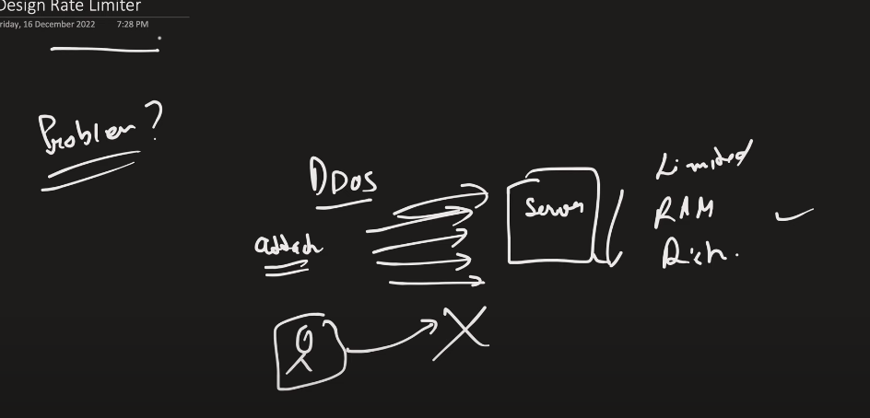

The problem is ddos ie attacker send thousands and millions of request in seconds which leads to consumption of resources of server ie ram storage etc and which eventually brings the system down and real users are affected with this.

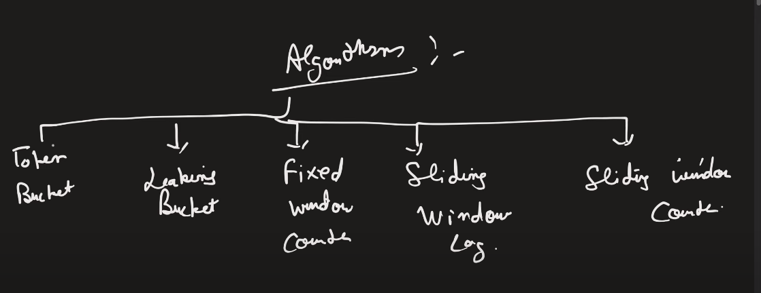

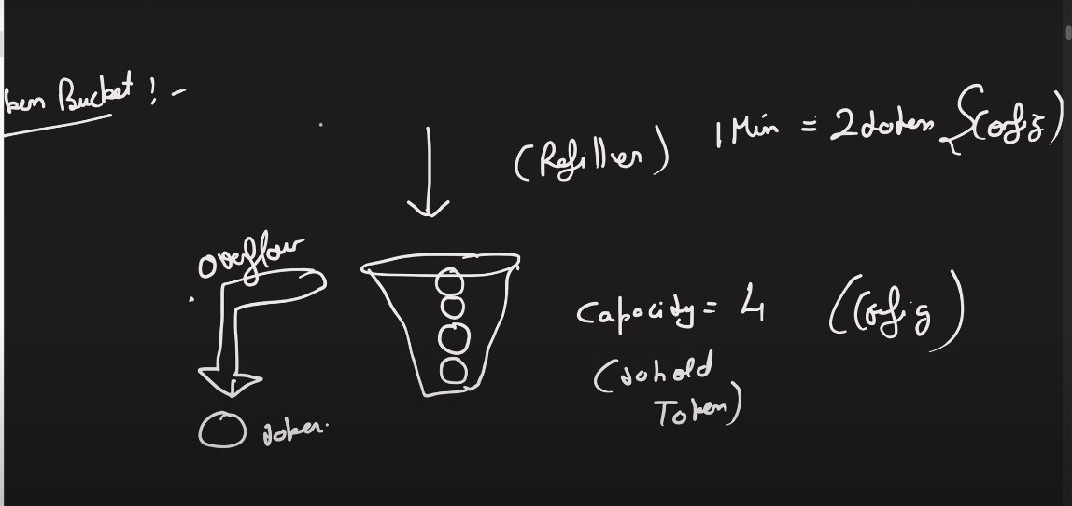

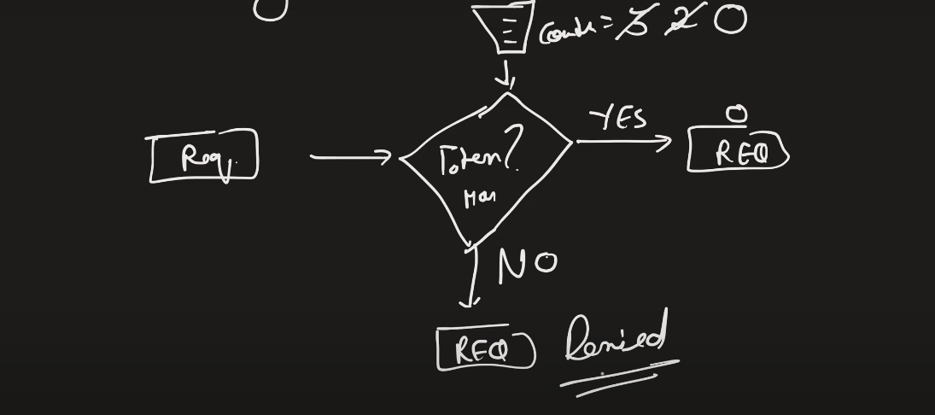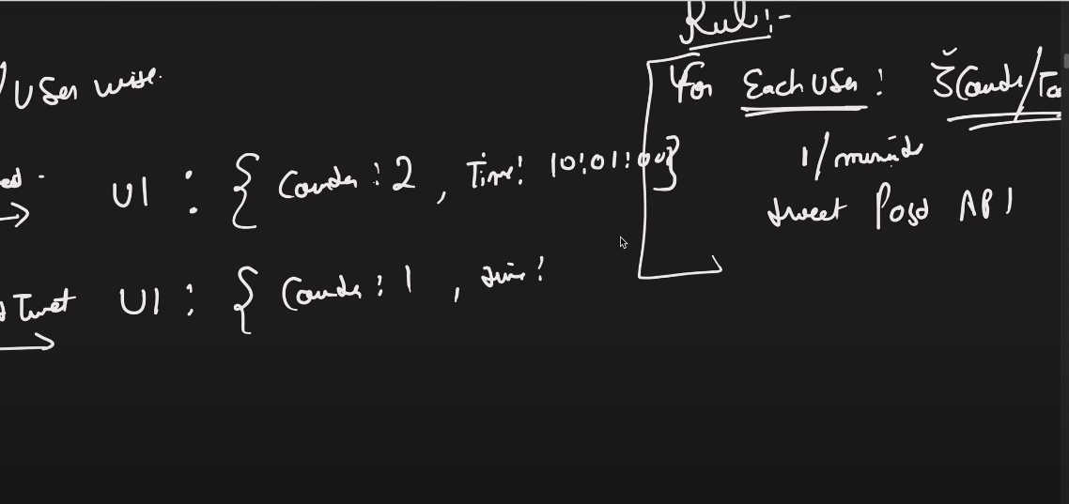status code – 429 when request access rejected.

## What Is Rate Limiting?

Rate limiting is a technique to limit network traffic to prevent users from exhausting system resources. Rate limiting makes it harder for malicious actors to overburden the system and cause attacks like [Denial of Service](https://www.imperva.com/learn/ddos/denial-of-service/) (DoS). This involves attackers flooding a target system with requests and consuming too much network capacity, storage, and memory.

APIs that use rate limiting can throttle or temporarily block any client that tries to make too many API calls. It might slow down a throttled user’s requests for a specified time or deny them altogether. Rate limiting ensures that legitimate requests can reach the system and [access](https://www.imperva.com/learn/application-security/broken-object-level-authorization-bola/) information without impacting the overall application’s performance.

## Why Is Rate Limiting Important?

Rate limiting is a crucial part of a modern [cybersecurity](https://www.imperva.com/learn/application-security/cyber-security/) strategy. It addresses several attack techniques that affect the incoming request rate.

### Distributed Denial of Service (DDoS)

A [DDoS attack](https://www.imperva.com/learn/ddos/ddos-attacks/) attempts to overwhelm the target system with traffic, making it unavailable to legitimate users. Rate limiting mitigates DDoS threats by preventing any given traffic source from sending too many requests.

However, DDoS attacks have unique challenges because they distribute requests among many different sources, sometimes millions of IP addresses. Distributing the attack allows each source to avoid exceeding the rate limit. The security solution should identify the requests from different locations as part of a single attack, treating them as a single source.

## How Does Rate Limiting Work?

Rate limiting works within applications, not in the web server. Rate limiting typically involves tracking the IP addresses where requests originate and identifying the time lapsed between requests. IP addresses are the application’s main way to identify who has made each request.

Rate-limiting solutions work by measuring the elapsed time between every request from a given IP address and tracking the number of requests made in a set timeframe. If one IP address makes too many requests within the specified timeframe, the rate-limiting solution throttles the IP address and doesn’t fulfill its requests for the next timeframe.

Rate-limited applications can tell individual users to slow down if they make requests too frequently. It’s akin to police officers pulling over drivers that exceed the speed limit or parents telling their children not to eat too much sugar in a short period.

## Types of Rate Limits

Administrators can define different parameters and methods and parameters when setting a rate limit. An organization’s chosen rate-limiting technique depends on the objective and the required level of restriction. Here are three main approaches to rate limiting that an organization might implement:

* **User rate limits**—this is the most popular rate-limiting method. It identifies the number of requests a given user makes, usually by tracking the user’s IP address or API key. Users that exceed the specified rate limit will trigger the application to deny any further requests until the rate-limited timeframe resets. Alternatively, users can contact the developers to increase the rate limit.
* **Geographic rate limits**—developers can further secure applications in a given geographic region by setting a rate limit for each specific region for a specified timeframe. For example, developers might predict that users in a given region will be less active between midnight and 9:00 am and define a lower rate limit for this timeframe. This approach helps prevent suspicious traffic and further reduces the risk of an attack.
* **Server rate limits**—developers can set rate limits at the server level if they define a specific server to handle parts of an application. This approach provides more flexibility, allowing the developers to increase the rate limit on commonly used servers while decreasing the traffic limit on less active servers.

## What Are the Algorithms Used for Rate Limiting?

There are several types of rate-limiting algorithms.

### Fixed-window Rate Limiting

Fixed-window rate limiting algorithms restrict the number of requests allowed during a given timeframe (window). For instance, a server’s rate-limiting component might implement an algorithm that accepts up to 200 API requests per minute. There is a fixed timeframe starting from a specified time—the server will not serve more than 200 requests between 9:00 and 9:01, but the window will reset at 9:01, allowing another 200 requests until 9:02.

Developers can implement a fixed-window algorithm at the server or user level. Implementing the algorithm at the user level will restrict each user to 200 requests per minute. In contrast, a server-level algorithm will restrict the server, meaning that all users combined can make up to 200 requests per minute.

### Leaky Bucket Rate Limiting

Leaky bucket rate limiting algorithms differ from fixed-window algorithms because they don’t rely on specified timeframes. They focus on the fixed length of request queues without considering the time. The server will service requests on a first-come, first-serve basis. New requests join the back of the queue. The server will drop a new request if it arrives when the queue is full.

### Sliding-window Rate Limiting

Sliding-window rate limiting algorithms are similar to fixed-window algorithms except for the starting point of each time window. With sliding-window rate limiting, the timeframe only starts when a user makes a new request, not a predetermined time. For instance, if the first request arrives at 9:00:24 am (and the rate limit is 200 per minute), the server will allow up to 200 requests until 9:01:24.

Sliding-window algorithms help solve the issues affecting requests in fixed-window rate limiting. They also mitigate the starvation issue facing leaky bucket rate limiting by providing more flexibility.

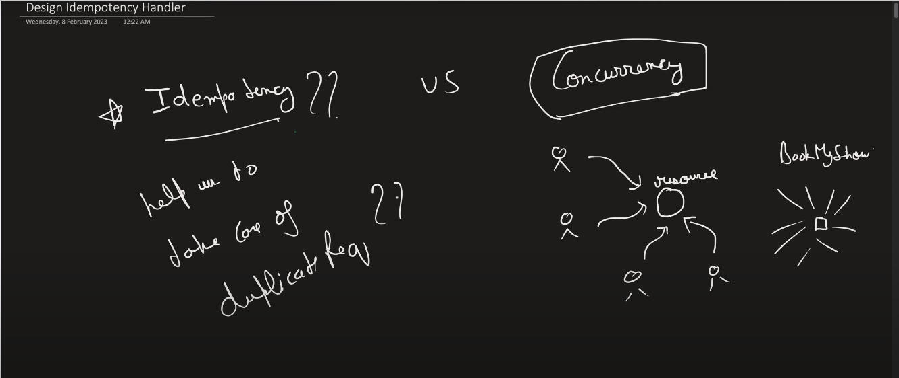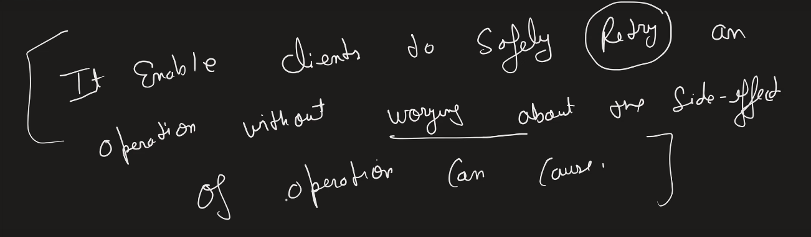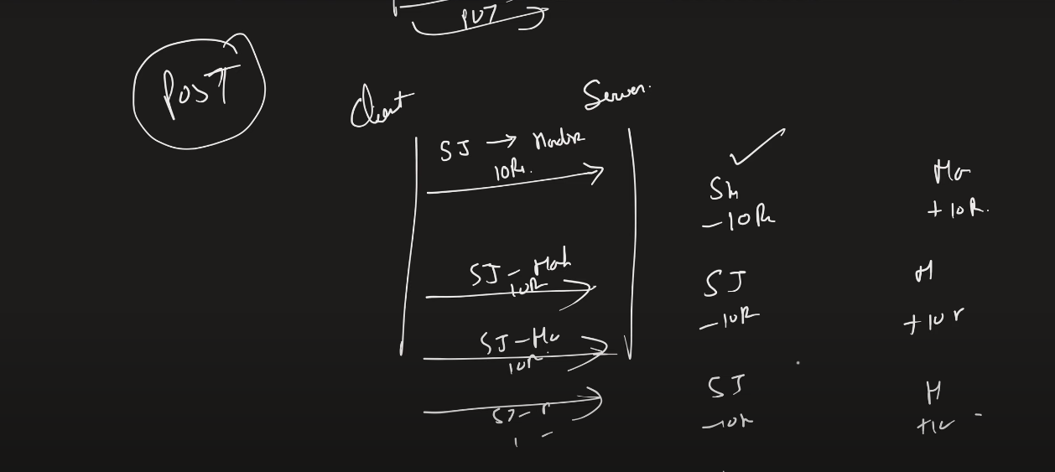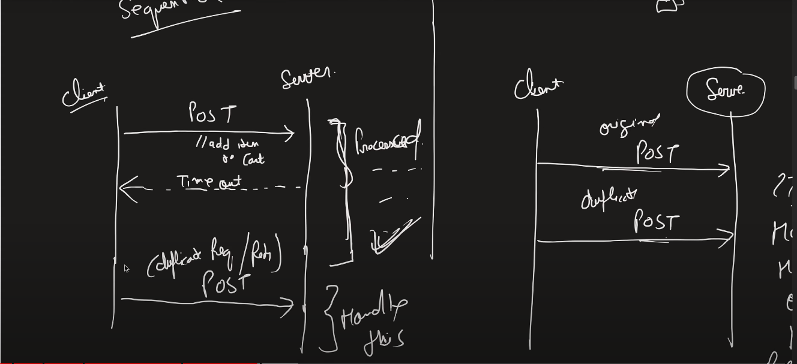sequential vs parallel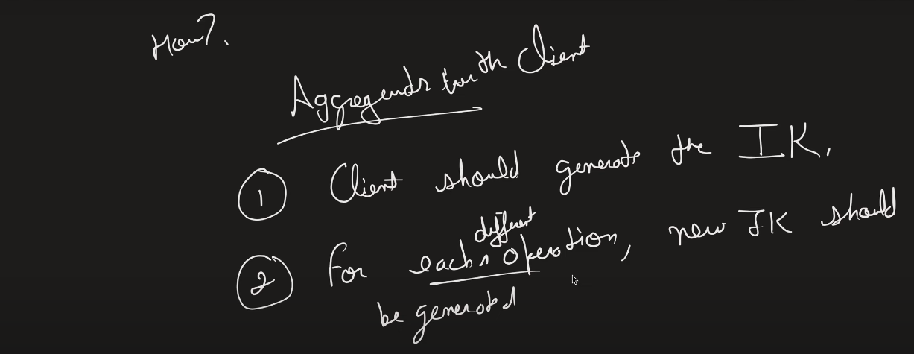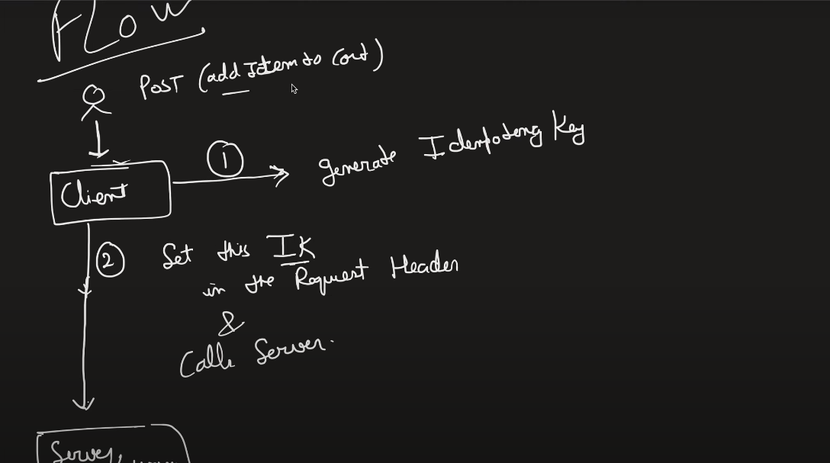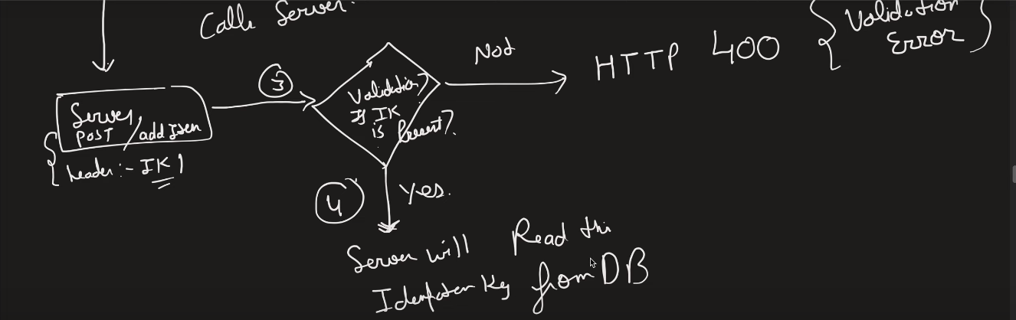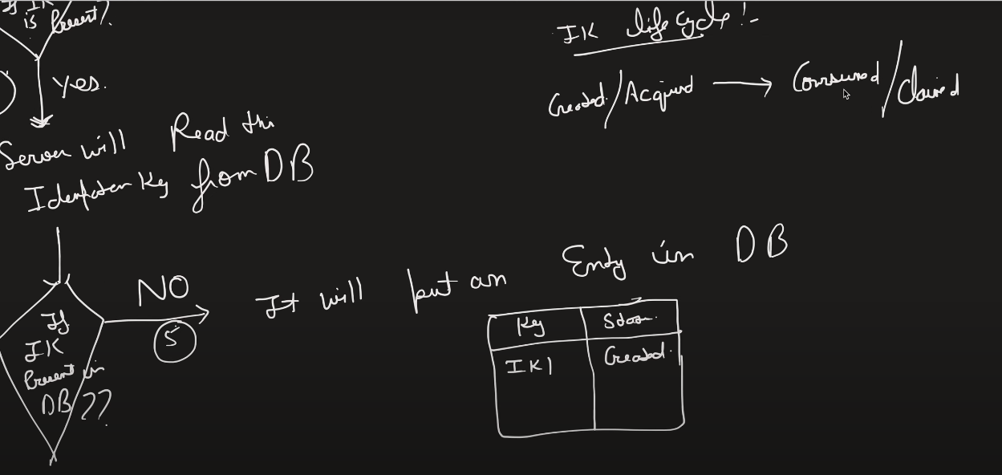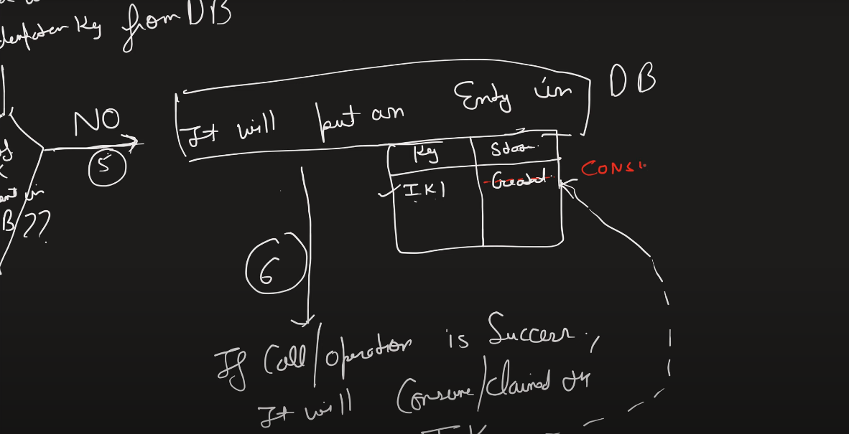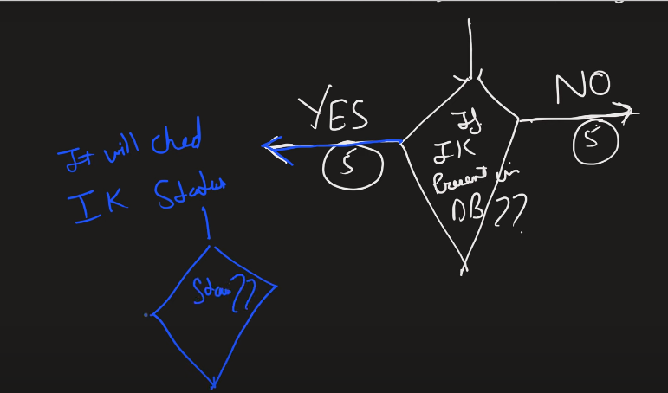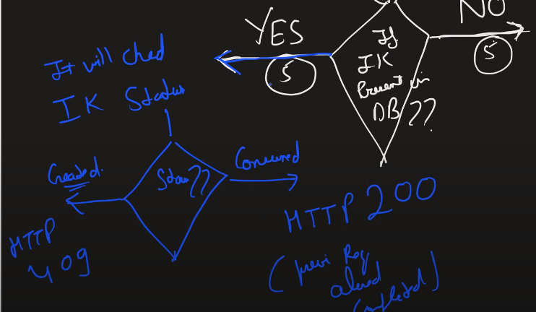when there is parallely two request with same idempotency key then it will result into duplicate record insertion into db that is wrong and we need to handle this using mutual exclusion and with the use of mutex or synchronized we need to acquire lock and process one request at a time. 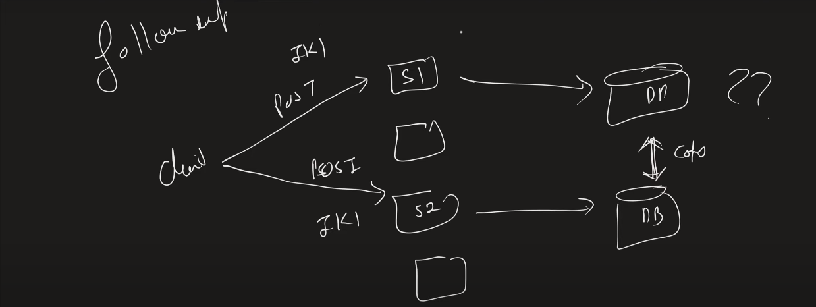for this we can add cache as the synchronization between the cache is very fast ie in millisecond so we put a lock on cache 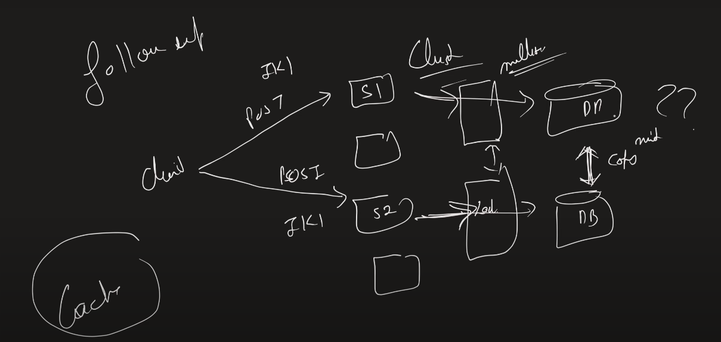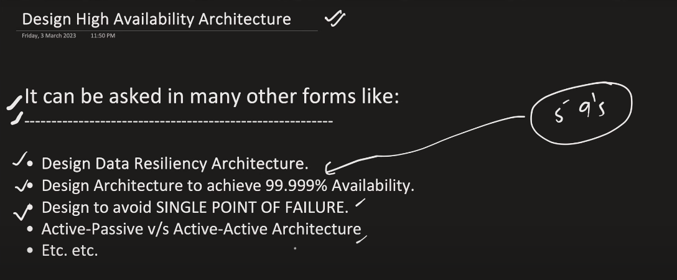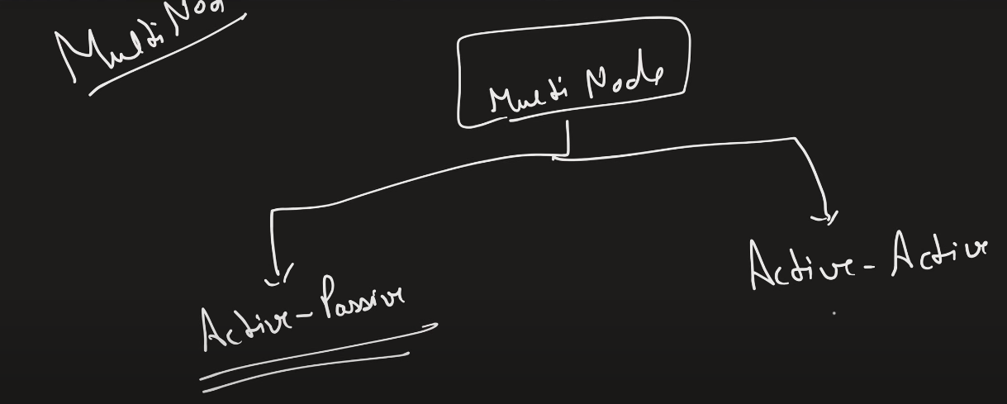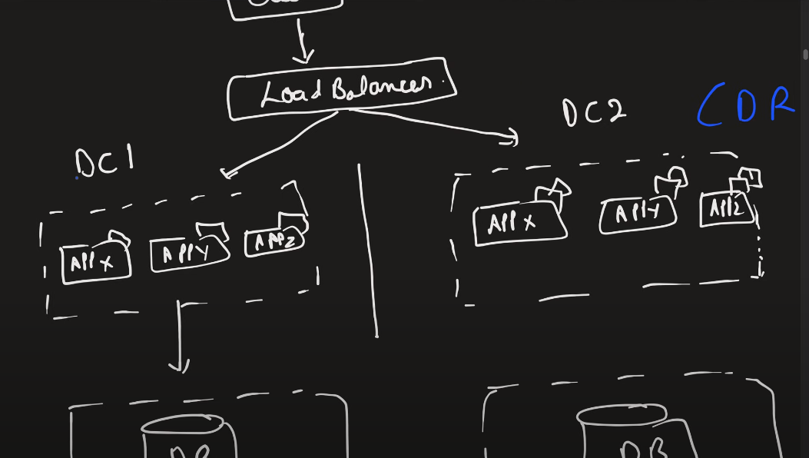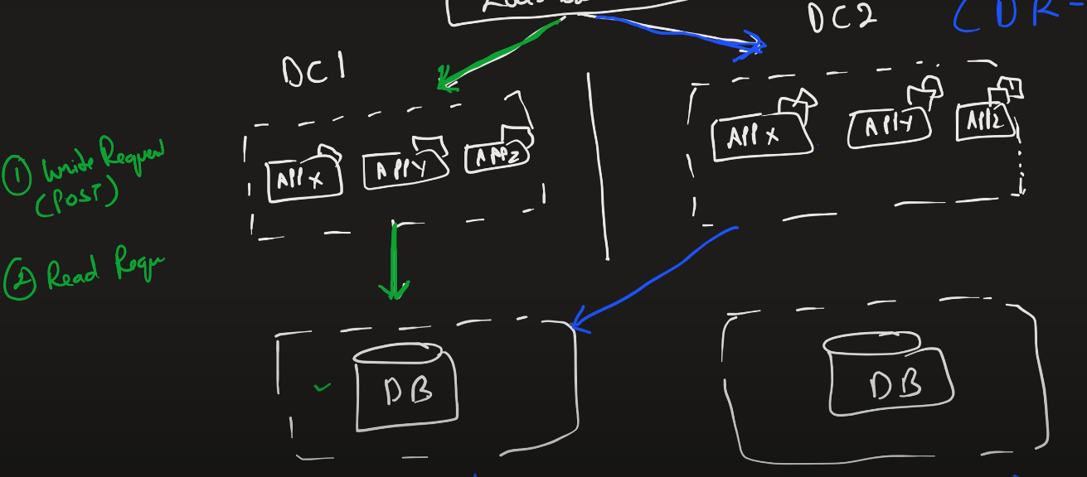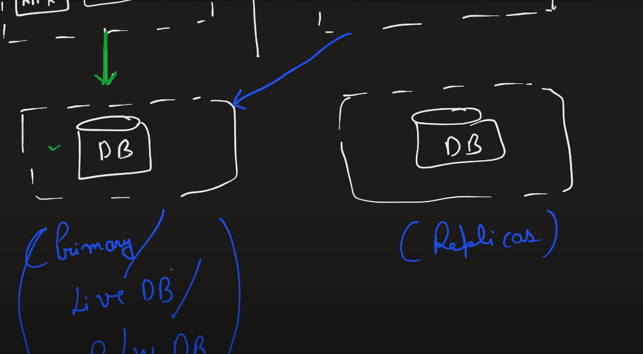in active-passive model there are almost 2 data center one is used for read/write which basically is my primary and other for read operation but if in case write request from load balancer goes to secondary db then the request will be routed to primary db and there will be synchronization between both the db from primary to replica.secondary also called disaster recovery data center.

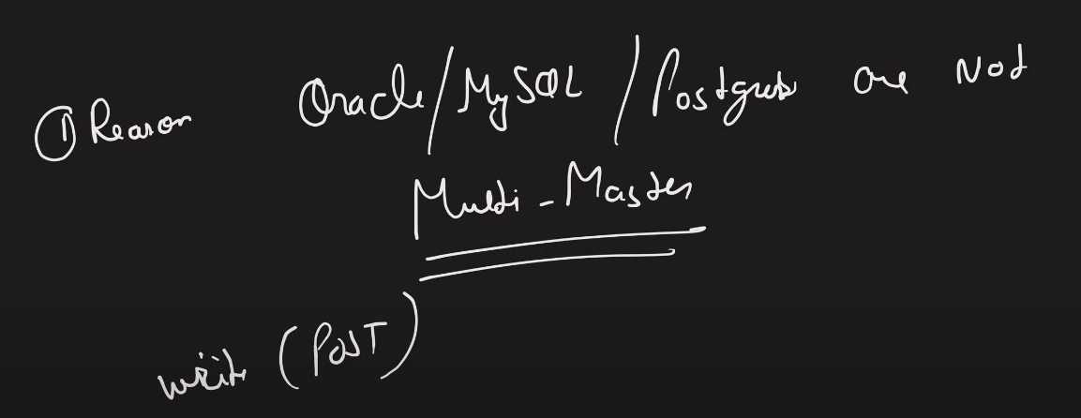

Mysql etc are not multimaster db ie they write only to master db.in case our master db goes down we can route the request to replica db and make it to primary and can perform read and write operations to it.

Disadvantages – 1 there will be increased latency when request goes to replica then it will pass the request to primary db which will increase latency.

2 when primary db goes down then there will be sometime of time gap lets say 5-10 mins then those write opertions will be failed.

In active-active both the db will act as primary and every request from both the db can be enternained as read/write but main challenge is when syncing the db.eg when each db is concurrently writing to each other their could be conflict and when if write is done on one db and read is from another db then there will be data inconsistency. 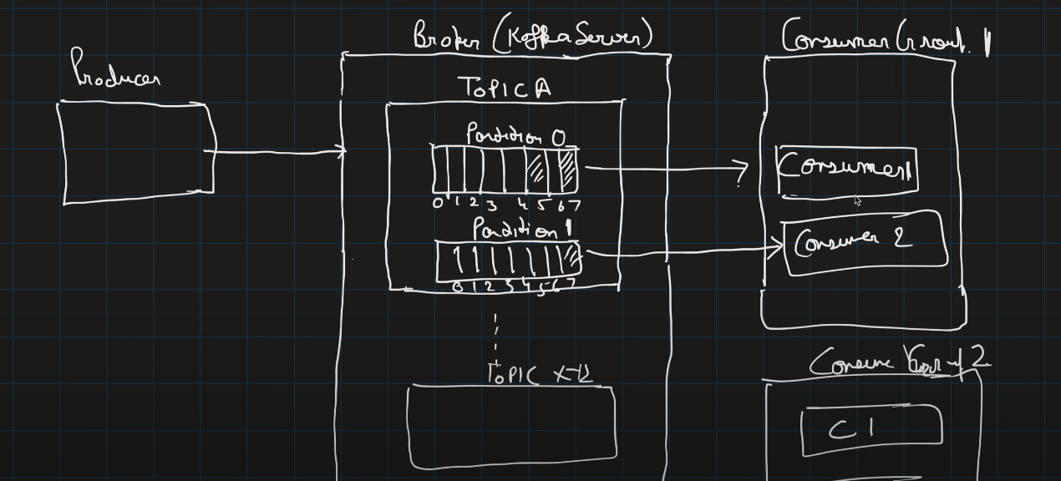in consumer group one consumer can consume one partition.but consumer in other consumer group can read partition that is read by other consumer in other group. 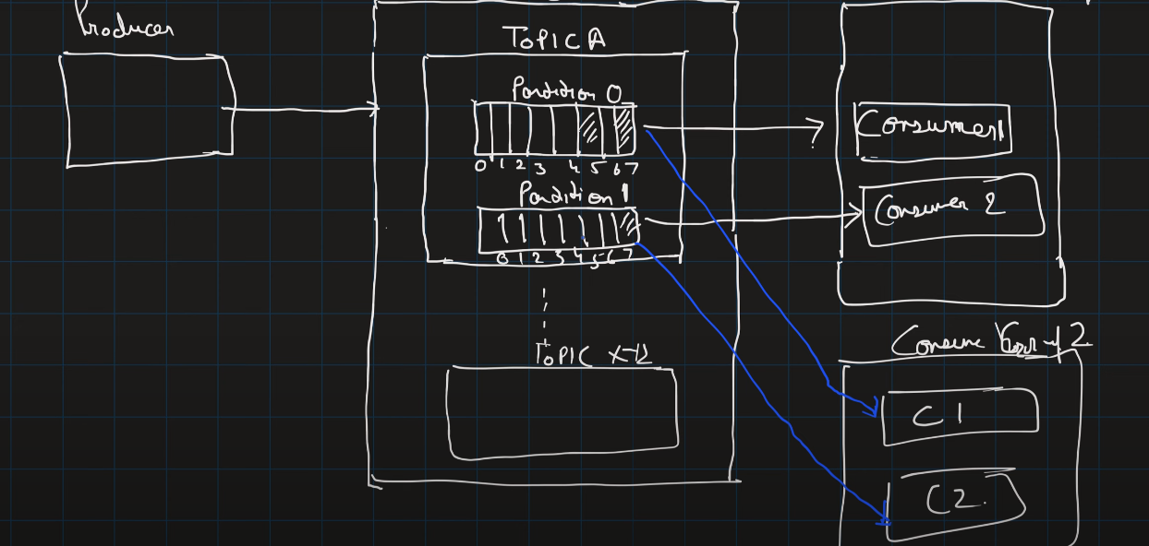if consumer goes down then with the help of the committed offset other consumer csn dtsrt read from that index (and the state of brokers are maintained by the zookeeper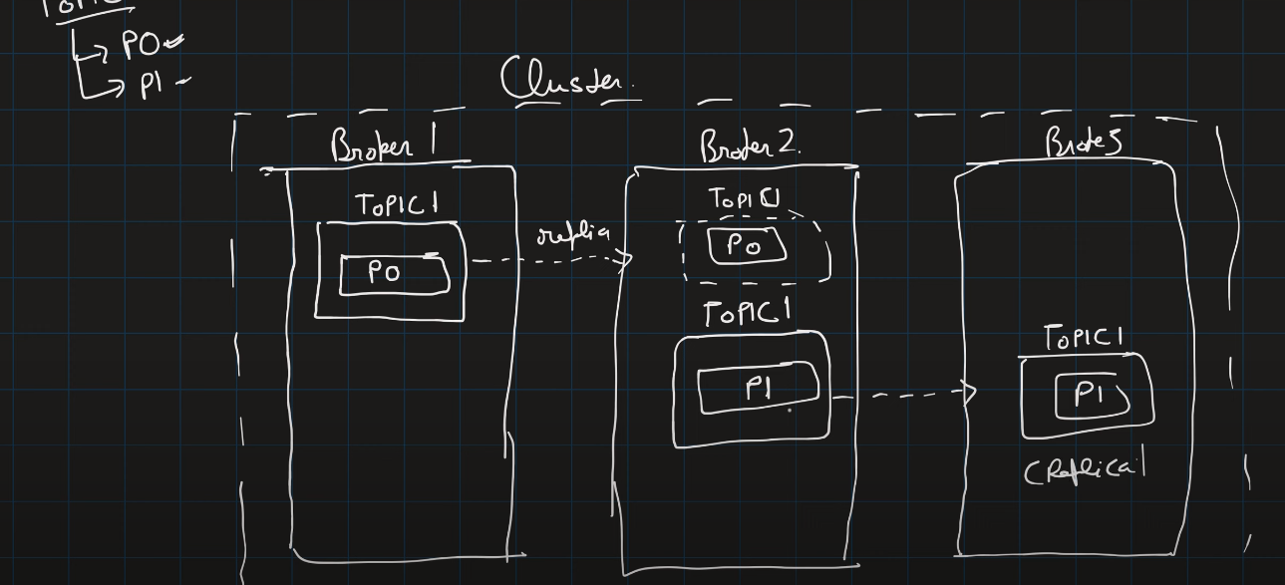). When consumer goes down then another consumer takes over from the offset where it left then process from the offset where it left.

When consumer is unable to read msg then after exceeding its retry limit we can add that msg to dead letter queue/failure queue and after analyzing out it back into the queue. Kafka is pull based approach ie consumer keeps on pulling whether the msg in available or not.